**DATA PROCESSING PROCEDURES 03:**

**DATA FINALIZATION**

**Table of Contents**

1. Introduction 4

2. What do you Need Before Starting Final Closing 5

3. Order of Operation 6

4. Creating a Hierarchical Dictionary “ccIQ80.DCF” 7

4.1 Appending <HH> and <IN> Dictionaries 7

4.2 Adding the ID Variable to the Individual Level 9

5. Data Concatenation 10

6. Concatenate Household Data 10

6.1 Household PFF File 12

6.2 Individual PFF File (Women and Men) 12

6.3 Household + Individual PFF File 13

6.4 Transmittal Sheet Barcodes PFF File 13

7. Running Original Structure Check Application “LSTClust” 14

8. Sorting 14

8.1 Sort PFF File 15

9. Reformatting the Data Dictionary 16

9.1 Reformatting Output Dictionary 16

9.1.1 Records and Items to be Deleted 16

9.2 How to Reformat with CSPro 17

10. Data Structure Check “CheckId” 19

10.1 Creating the Structure Check Application “CheckID” 19

11. « Others » responses 21

11.1 Others Data Concatenation 22

11.1.1 Others Concatenate PFF File 22

11.1.2 Sorting (1) “Others” Data 22

11.1.3 Summarization of “Others” Responses (OTHSUMM.APP) 23

11.1.4 Exporting “OTHSUMM.DAT” into Excel 24

11.1.5 Running Frequencies to Check “New Values” (QReclass) 28

11.1.6 Copying the “New Values” Back to the Original “Others” (OTHCOPY) 28

11.1.7 Sort (2) – OTHSort2.ssf 29

11.1.8 Replace “Others” Responses New Values into the Main Questionnaires Dataset (OTHRepl) 29

12. Calculation of Sample Weight 31

12.1 Exporting “FinalWeight” Worksheet into ASCII Format 33

13. Secondary Editing and/or Imputation (ccImpute) 36

13.1 Creating “ccImpute” Application 37

13.2 Common SE Messages 39

14. Nutrition Z-score (FinImp) 46

14.1 List of Working Variables in the “FinImp” Application 47

14.2 Converting “FinImp” Standard Application to Survey Specific 48

14.2.1 Creating Survey Specific Application for FinImp 48

14.2.2 Adjusting “FINIMP” Application Using Text Editor 49

14.2.3 Calculation of WHO Height-and-Weight Z-scores 51

15. Key Indicator Report 53

# 1. Introduction

This chapter sets out the procedures and guidelines for the closing trip of a DHS survey. The main objectives of closing a survey are to generate the final raw dataset, to generate the first draft to the recode dataset and produce the first batch of the key indicator report (KIR). There are many tasks that need to be carried out to wrap up a survey and the majority of them should be implemented in country. However, the preparation of all the application should start before traveling.

As part of the final trip, it is also expected that the data manager specialist prepares the necessary exports application. The raw data should be exported to SAS, SPSS and STATA format and should be left in country together with the export applications.

Each closing activity will be discussed in this document in more detail and will be listed in a specific order of operation for a full DHS survey that includes all the modules and biomarkers.

Before starting the preparation of the closing trip it is the responsibility of the data manager specialist to gather all the external data required for some applications: Weight spreadsheet, GPS data set, occupation code manual, CS education system, final sample file variable, wealth index (optional). If HIV DBS and/or Malaria microscopy sample are been collected, make sure you have the scanned barcodes handy.

As a general rule, the final data processing trip should not be made until the implemented in-country agency has completely finished field work, all clusters have been received via IFSS and secondary editing and final archiving should have been completed for all clusters prior to the visit of the data processing specialist. The reason for this requirement is that most of the steps to finalizing the data file require the existence of a complete, edited dataset to work on, thus it is not usually time or cost-effective for the data processing specialist to spend time in country waiting for data processing to be finished.

An exception to this rule can be made if the presence of the data processing specialist is required to ensure that in-country processing is completed within a reasonable time, or if earlier arrival is required to allow overlap in-country with a survey manager. In these cases, allowance should be made in terms of scheduling and budgets for the fact that the data processing trip will almost certainly be longer than three weeks.

*Note: The data processing specialist should use OneNote to take notes and to write down special comments and any other issues that should be documented as part of the whole process of closing a survey.*

# 2. What do you Need Before Starting Final Closing

**Standard subfolders**

* \Prelim (contains most of the programs used for closing a survey)
* \Anthrop (Standard applications used to calculate the new WHO z-score for the

anthropometric indicators)

* \Exports (standard application to export the raw data to SPSS/SAS/STATA)
* \Findata (mainly used to store all concatenated version of the final data)
* \Others (All programs for the other responses reclassification)
* Matmort (Maternal mortality imputation programs, if applicable)
* \HIV (Programs to edit and reconcile the HIV lab barcodes with main questionnaires

data)

* \Malaria (same as HIV but for malaria microscopy lab barcodes)
* \Recode (household, women and men recode programs and “consis” application)
* \Tables (Final report tables applications)
* \Wealth (Wealth index CSPro application)

**Dictionaries**

* Weights.dcf
* WealthIndex.dcf
* Recode7.dcf
* MRecode7.dcf
* HIVTestdat.dcf

**External data files**

* Weights for household, women, men (if applicable), domestic violence (if applicable) (Excel spreadsheet by sampler specialist)
* Others reclassification (by the in-country DP staff)
* GPS data
* Scanned barcodes (if HIV DBS and/or Malaria microscopy)
* Wealth index scores

**The data processing specialist should ensure that all programs and other files required for the final visit are prepared beforehand. They should also be tested as extensively as possible using existing data from the field, prior to the final visit.**

# 3. Order of Operation

Always start with a check of clusters against the sample file. Also, check that all clusters file are accompanied by an “others” data file. *It’s very unusual that a cluster data file does not have the corresponding “others” data but can be possible.*

When these checks are completed:

|  |  |  |  |
| --- | --- | --- | --- |
| **Action** | **Dictionary** | **Application** | **Comment** |
| Create hierarchical dictionary | ccIQ80 |  |  |
| Concatenate data file: |  |  |  |
| Household data | ccHH80 |  |  |
| Individuals data | ccIN80 |  |  |
| Others “responses” data | OTHERS |  |  |
| Transmittal sheets data | TRANSMIT |  |  |
| Sort household and individuals data | ccHH80/ccIN80 | Sorthh.ssf/pff  Sortin.ssf/pff |  |
| Run LstClust application on concatenated files to check that the structure of the data is correct | ccHH80/ccIN80 | Lstclust | Modify to run on all files not a single cluster |
| Run frequencies (frequencies must be run after each step below) | ccHH80/ccIN80 |  |  |
| Other response reclassification | OTHERS |  | See separate section |
| Final Secondary editing | ccHH80/ccIN80 | Hhedit8/inedit8 | Run on concatenated data, corrections usually made on cluster level data |
| Imputation | ccHH80/ccIN80 | Hhedit8/inedit8 | Modify logic in applications to enable imputation. |
| Merge and sort household and individual level files into a single hierarchical file | ccIQ80 | Sortall.ssf |  |
| Add sample weight and stratification | ccHH80/ccIN80 | Hhedit8/inedit8 |  |
| Reformat data file to remove PII | ccIQ81 |  |  |
| Calculate the child nutrition standard deviation or Z-score | ccIQ81 | Finimp |  |
| Calculate the new WHO standard deviation of Z-score | ccIQ81 | WHOHWZ.apc, WHOWHZ15-19.apc | In Anthrop folder |
| Run imputation for Maternal Mortality (If the MM module is part of the survey) | ccIQ81 | MMImp8.apc | In MatMort folder |
| Add the wealth index | ccIQ81 |  |  |
| Merge in recoded others answers | ccIQ81 | Othcopy.apc, Othrepl.apc | Others folder |
| Calculate and add Ever-married inflation factors (if required) | ccIQ81 |  |  |
| Scramble IDs and sort data file (if DBS was collected) | ccIQ81 |  |  |
| Sort ID’s after scramble | ccIQ81 |  |  |
| Produce the KIR | ccIQ81 | KIRDHS-8.apc |  |
| Generate the recode data file for household, women, and men | ccIQ81, ccIR81 | Recode,Mrecode |  |
| Frequency review | ccIQ81, ccIR81 | Iqfreq8/hrfreq/irfreq |  |
| Consis application | ccIR81 | Consis7 |  |
| Generate the final report tables | ccIR81 | Chaptxx | Tables folder |
| Exporting the raw data file | ccIR81 |  |  |

The reclassification of the “other responses” is often a lengthy process. Open-end questions like occupation can have more than 10,000 lines on it owns. It takes more than one person and at least 2 weeks to recode the occupation only. Because time is very limited during the final data processing trip, it is worthwhile to prepare the excel spreadsheet with the summary distribution of the “other” responses before travelling and provide the listing (via email) to the person(s) who have been assigned the task to start recoding the “other responses” as soon as possible.

The sample weights can be calculated as soon as the recoding of the “other” answers is completed. Thus, the recoding of the “other” categories for the household, individual and male result codes have been completed, since the recoding in each of these result codes might have an effect on the sample weights.

Generally, the sample weights are added to the data file during the imputation process. If the imputation has already been completed (and for some reason cannot be repeated), then a separate batch application can be written. The same holds for the ever-married factors. Note however, that the sample weights are needed to compute the ever-married factors either by being available in the data file or as input in the applications that generate the ever-married factors. It is advisable to add the recoded “other” answers to the data file before the final imputation since the imputation will also check whether the recording of “other” answers introduced additional inconsistencies. It might, however, be necessary to deviate from this rule. *Don’t forget to add a frequency check whenever a new file is generated*.

The scramble of the data IDs and sorting the data after scrambling is always performed last.

# 4. Creating a Hierarchical Dictionary “ccIQ80.DCF”

The CAPI data entry system uses two dictionaries; one for the household and biomarker questionnaires “ccHH80.DCF”, and another one for the individuals (female/male) questionnaires “CCIN80.DCF”. To implement all closing data processing activities it is required to create a hierarchical dictionary by appending the household (HH) and individual’s (IN) dictionaries.

## 4.1 Appending <HH> and <IN> Dictionaries

Almost all dictionaries reside in the “Dicts” folder. Follow the steps below to create a hierarchical dictionary.

* On the “\Dicts” subfolder, make a copy of the household dictionary and rename it as “ccIQ80.DCF”
* Open ccIQ80.DCF using CSPro program
* 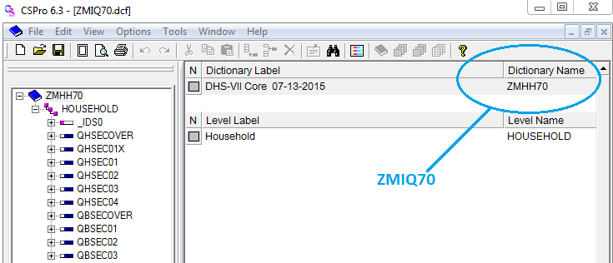Change the internal dictionary name as “ccIQ80”
* Right click on the *HOUSEHOLD* level and select “*Add level*”.

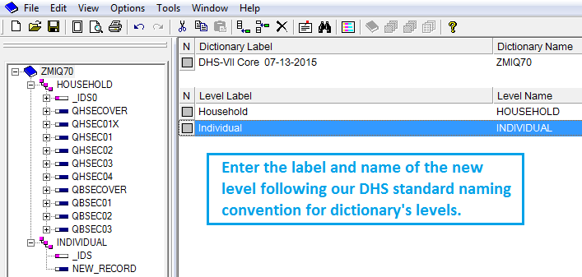

* 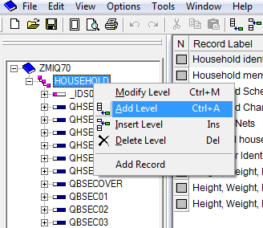Enter the level name and label, following our naming convention: INDIVIDUAL for women and men level.
* On a separate screen, go to the “\dicts” subfolder and open the data entry dictionary for individuals “ccIN80.DCF”
* 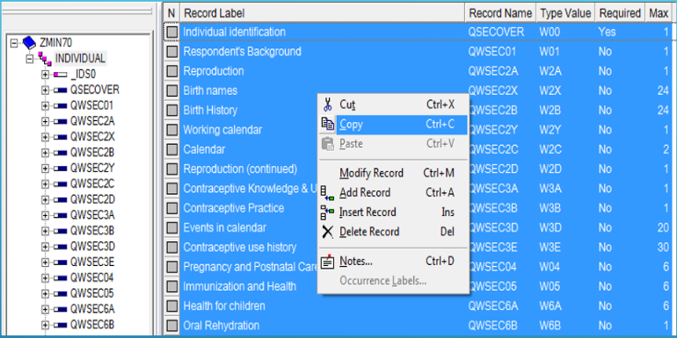Click on the level “INDIVIDUAL” and CSPro will show all the records in the right hand side panel.
* Select all the records
* Do right click and select the option “copy”
* Now, go to the screen where you have opened the “ccIQ80.DCF”
* 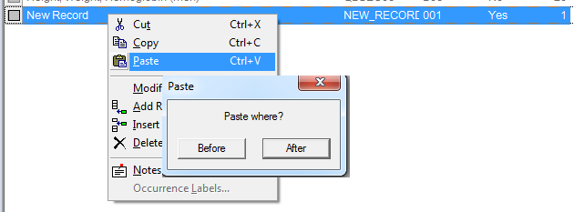Click on the “INDIVIDUAL” level
* On the right hand side panel, do right click on the “New record” and select “paste”
* Click on paste “after”
* CSPro will add all the records in the new dictionary after the record “new record”.
* 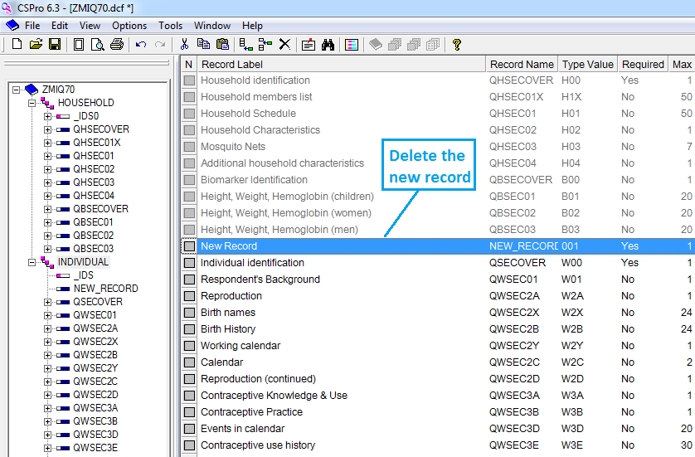Do not forget to delete the “new record” (see picture below).

## 4.2 Adding the ID Variable to the Individual Level

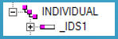

* Do right click on the IDS variable under the INDIVIDUAL level
* 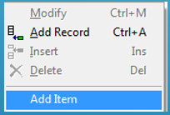Select “add item”
* On the right top panel enter the item label =”Line Number”, the item name = “QLINE”, the length = “2” and the zero field = “Yes”.

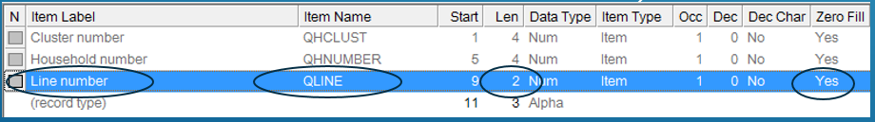

* Congratulations!!! The hierarchical dictionary is ready to start the closing activities.

# 5. Data Concatenation

Even though the central office closed clusters are under the subfolder “FINAL”, it’s recommended to concatenate the clusters data files stored under the subfolder “CLOSED”. The most common reason is that the data processing supervisor can forget to make a copy of the data files for a particular cluster after any secondary editing iteration. In such a case, it may be possible to find a no updated copy of the edited file on the \FINAL subfolder.

Six “concatenate” applications should be created for a full DHS survey including DBS and malaria microscopy test:

1) household data files,

2) individual data files,

3) household and individual data files as the first step to creating the hierarchical data file

4) DBS transmittal sheet (if applicable),

5) malarial transmittal sheet (if applicable)

6) Others responses.

If the geographic points were collected as part of the CAPI system, you should consider creating another concatenate application to collapse the geographical coordinate’s data file.

# 6. Concatenate Household Data

* Select CSPro tools option “Concatenate”
* On the concatenate screen, enter the required information:
  + 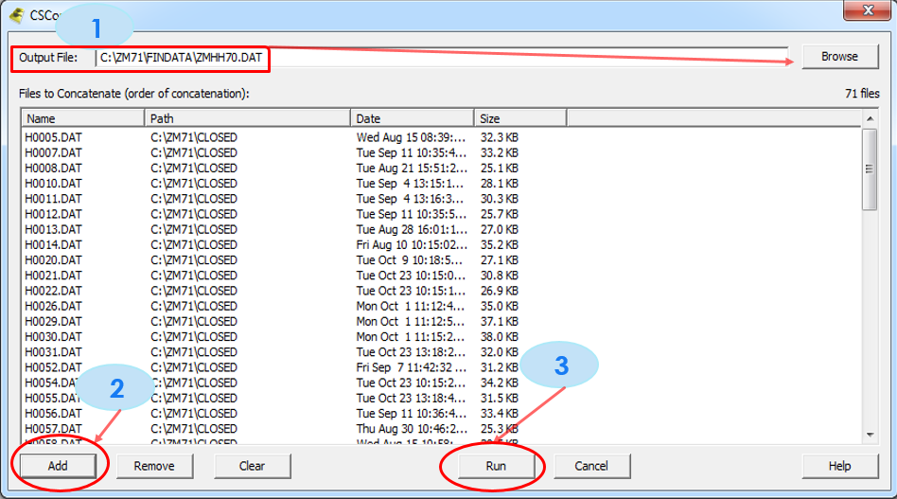1) *The output data file*. As part of the DHS standard procedure, all concatenated data file should be saved under the subfolder named “\FinData” and the naming convention for the HH data files is “ccHH80.dat”
  + 2) Click the *“Add” bottom* and go to the subfolder where the household data is and select all the “H????.dat” files and click “Open”. CSPro will add in the middle panel all the files names to be concatenated.
  + 3) Lastly, click on the *“Run” bottom* to execute the concatenate application.
  + If the file already exists, cspro will ask if you want to replace it. Click “Yes”
  + A box with “concatenate complete” will show
  + 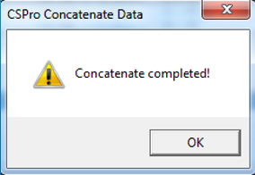Click “Ok” to finish
  + 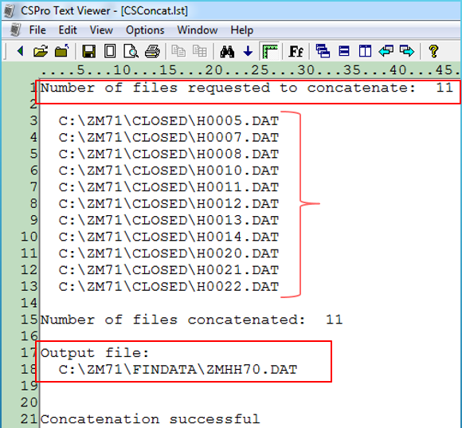“CSPro Text Viewer” will open the list file with relevant information that can be used to validate the total number of clusters expected in the sample, the name and path of the output data file.

Every time the concatenate tool is run, CSPro will create an executable, named “CSConcat.pff” in the same path where the output data file will be saved. Concatenate is a process that has to be run multiple times as part of the final editing process. To avoid going thru all the steps described above, move the executable file “CSConcat.pff” to the \prelim subfolder and renamed it “HHConcat.pff”. Just double-clicking on it to run every time needed.

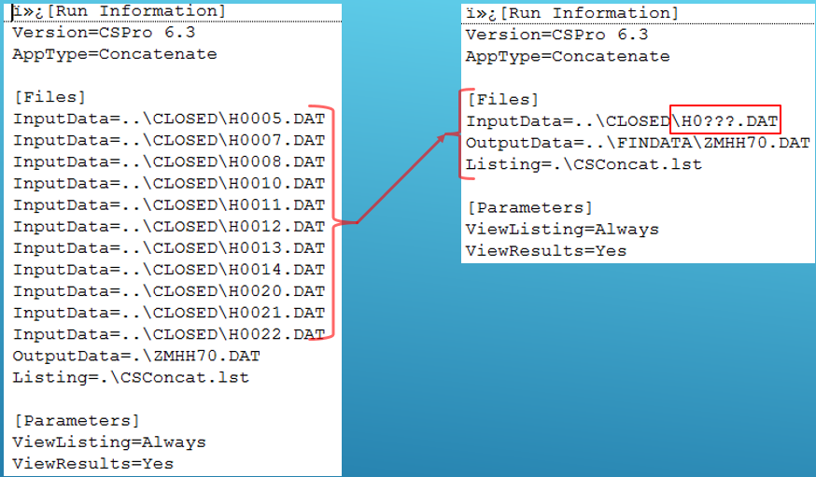Note: the “HHConcat.pff” can be edited using any text editor in order to use a wildcard to replace the path of each cluster data file.

## 6.1 Household PFF File

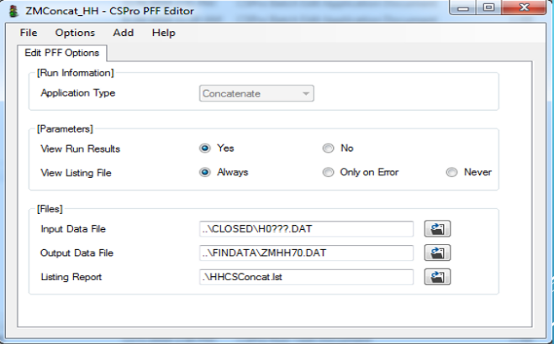

***Application name***: ccConcat_HH.Pff

Input data file: H????.dat

Output data file: ccHH80.DAT

***Listing report:*** ccConcat_HH.lst

Note: it’s highly recommended to always check the report file to make sure that the output data file contains all the expected files.

## 6.2 Individual PFF File (Women and Men)

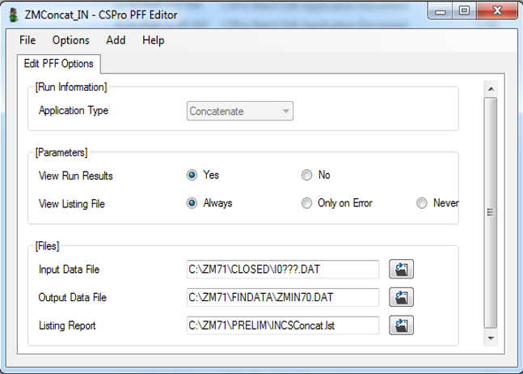

***Application name***: ccConcat_IN.Pff

Input data file: I????.dat

Output data file: ccIN80.DAT

***Listing report:*** ccConcat_IN.lst

## 6.3 Household + Individual PFF File

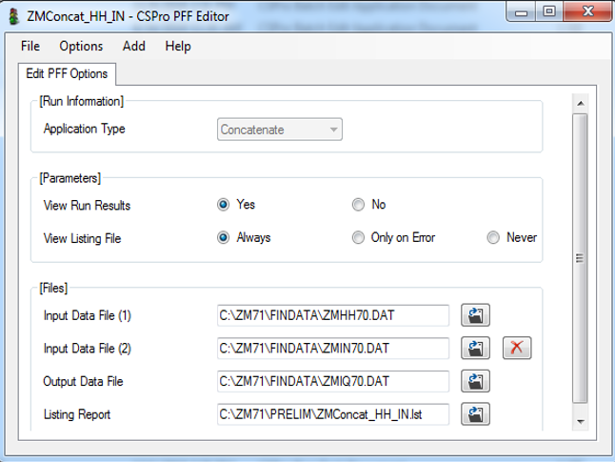

***Application name***: ccConcat_HH_IN.Pff

Input data file: ccHH80.DAT

Input data file: ccIN80.DAT

Output data file: ccHHIN80.DAT

***Listing report:*** ccConcat_HH_IN.lst

## 6.4 Transmittal Sheet Barcodes PFF File

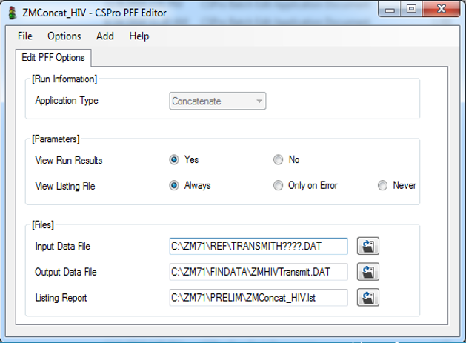(Only if survey includes HIV DBS testing). This file can be found under the \REF subfolder and there will be one file per team.

***Application name***: ccConcat_HIV.Pff

***Input data file***: TransmitH????.dat

***Output data file***: ccHIVTransmit.DAT

***Listing report:*** ccConcat_HIV.lst

Note: if the survey includes malaria microscopy or any other BM that requires barcodes, repeat this step by making a copy of this application and changing the names to MAL instead of HIV.

# 7. Running Original Structure Check Application “LSTClust”

Before creating the hierarchical data file, it is highly suggested to run the original version of the structure checks programs “lstclust” that can be found under the Central Office folder *(\Central)*. This application should be run on the concatenated non-hierarchical files (see point 6.1.1 and 6.1.2) as one of the first steps prior to generating the hierarchical file for households and individuals. Mainly, if there are issues discovered at this time, it may save considerable time and extra work to resolve any issue encountered, plus you would prefer to know that you are working with a data file that is in a good structural shape prior to merging.

a) Make a copy of the “lstclust” application files to the prelim folder

b) When running the application make sure to use the data files as shown in the .pff file below:

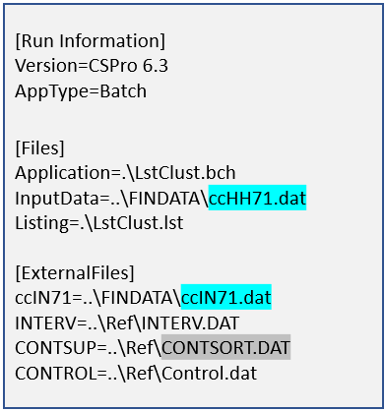

# 8. Sorting

Sorting is the next step that follows the process of the concatenation of all households and individuals data. In the appended data file (ccHHIN80.DAT) all the households are listed first and individuals are appended at the very last. By sorting the data, each individual will be placed right after the household they belong to, organized by the line number.

The key variables for sorting are the questionnaire’s IDs variables: typically, cluster number, household number, and individual line number. The standard applications for sorting the data file can be found under the \PRELIM subfolder. This application consists of two files: SortAll.ssf and SortAll.ssf.pff.

To convert the standard applications into country-specific, rename the two files by adding the country code “ccSortAll.ssf” and “ccSortAll.ssf.pff”. Open the PFF file using the CSPro Pff editor and made the necessary adjustment to the input and output data file following the DHS naming convention.

Do not forget to open the “ccSortAll.ssf” using a text editor and replace the standard dictionary name by the CS dictionary name

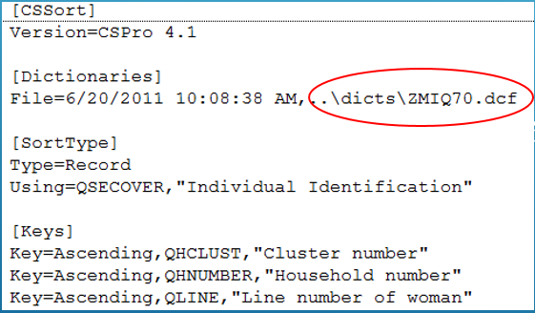

## 8.1 Sort PFF File

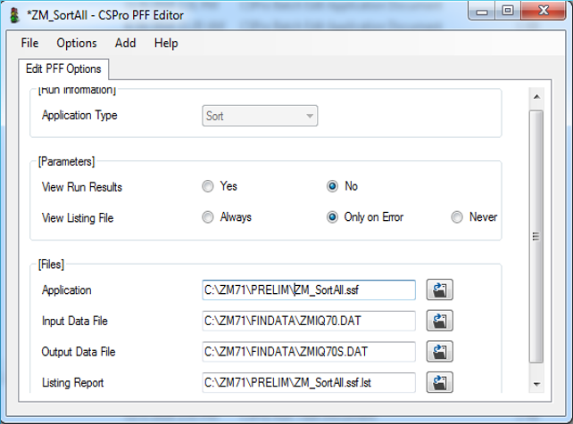***Application name***: CC_Sortall.Pff

Input data file: ccHHIN80.dat

Output data file: ccIQ80.dat

Listing report: ccSortall.lst

# 9. Reformatting the Data Dictionary

Reformat is a CSPro tool that allows you to reorganize data records, lengthening data items and delete/add data record or data items. Reformat changes the data structure from one file format to another using an input and output data dictionary. Fields with corresponding names are copied from the input to the output file.

Reformatting the data dictionary serves two purposes:

1. To remove variables that contain PII (personal identifying information), such as names
2. To remove working variables that are needed for CAPI data collection but do not need to be included in the final data set. Before running the cspro reformat tools, the output dictionary should be set properly.

**Note that it is mandatory to remove ALL PII fields from the data dictionary before distributing the data set to any person outside the survey team. Removing PII fields early in the data finalization process reduces the risk of exposing PII data.**

## 9.1 Reformatting Output Dictionary

* Go to the \DCFTS subfolder and make a copy of the hierarchical dictionary ccIQ80.DCF and rename it to “ccIQ81.DCF”
* Open “ccIQ81.DCF” in CSPro
* Delete the unnecessary records and items. See below the list of standard records and variables that should be removed. *Keep in mind that this rule applies to any country specific record or country specific variables with PII information:*

DO NOT FORGET*: to avoid having blank space gaps within records, after deleting variables the relative position should be readjusted*.

### 9.1.1 Records and Items to be Deleted

The Demographic and Health Surveys Program (DHS Program) is committed to protecting the identity of the respondents to the DHS surveys and to maintain the confidentiality of the data collected. To comply with this commitment, one of the data finalization steps is to remove all personal identifiable information (PII). To preserve data anonymity, the following PII variables must be trimmed:

**Names and addresses:** In CAPI surveys it is necessary to enter addresses and names electronically. Addresses are required for locating the selected households, and names are important for identifying individuals eligible for different types of questionnaires, as well as for the measurement of biomarkers. Names may also be used to customize the survey questions to facilitate the interview process.

**Geographical variables**: Any geographical variables below the reporting survey domain must also be deleted*. If it is necessary to maintain some of these geographical variables in the data file, the reason for keeping them should be indicated in the recode documentation*.

**Temporary variables**: CAPI data capture system includes few working variables with the purpose to smooth the data flow, verification, consistency checks, and for probing. Those variables are only needed during data collection and should also be deleted before reformatting.

**List of record and variables to be deleted**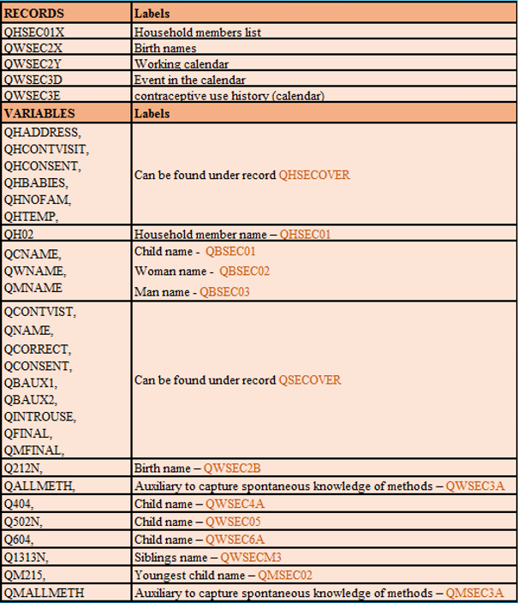

## 9.2 How to Reformat with CSPro

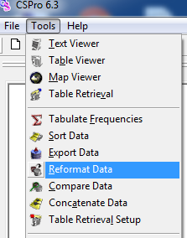To run the reformat tool, open the **Tools** menu and select “Reformat”

* A screen will pop up to enter the following information:
  + *input dictionary* and the data file “ccIQ80.DCF – ccIQ80S.dat (sorted)”
  + *output dictionary* and data file “ccIQ81.DCF -- ccIQ81.DAT”

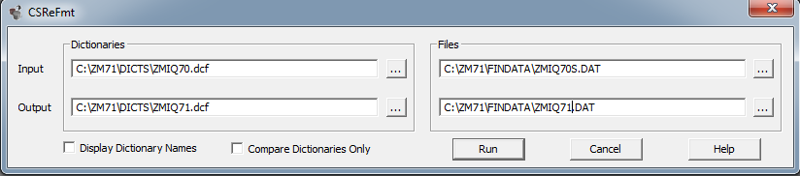

* Click the bottom “Run” and CSPro will list the files compare the result
* Click the “continue” bottom and CSPro will execute the reformat and will open the “lst” file with “CSPro Text-Viewer”.
* CSPro will automatically create an executable file called “CSRefmt.pff” under the \DCFTS subfolder with all the parameters you entered in the screenshot above.

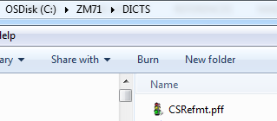**Note:** *The reformat process should be run multiple times during the survey closing process. To avoid entering the reformat information every time you need to repeat this task; it’s recommended to move* “CSRefmt.pff *to the \PRELIM subfolder and rename it as “ccRefmt.pff”. By double-clicking it, CSPro will run the reformat.*

# 10. Data Structure Check “CheckId”

The CheckID application is used to check that the final reformatted dataset complies with the dictionary structure and the questionnaires skips and filters pattern. It also checks sample/subsample design by making sure that all households in the sample have an entry in the final data and all individuals eligible for interview are present and properly link to the households they belong to. More specifically, the checkID application checks the internal structure of each data node and will list error messages if missing records or extra records are found. Furthermore, and more importantly, this application checks the denominator of each section or module of the entire questionnaires.

The structure check program is usually run thru several stages during data collection; first by the supervisor before closing any given cluster, and second by the central office before secondary editing. During data collection, every time the supervisor receives from the interviewers, the structure check is activated as a background application to verify the integrity of the data. The central office system also run the structure program after receiving closed clusters from the field, to make sure that the data files were not corrupted during the transferring process.

As part of the closing activities, the structure check should also be run several times on different stages of the closing activities. This is to certify that the integrity of the final dataset is not altered by any of the programs use to close a survey. The “Check ID” program that will be used is the same program used during data collection “LstClust.app” -with some modifications-, located under the \central subfolder, with the difference that the new application will use the CS hierarchical and reformatted dictionary “ccIQ81.DCF”.

When the CheckID program has been prepared correctly, it will generate a list of structure errors, if any, and a list for all clusters with the number of complete and incomplete household and individuals. Any message indicating structure errors should be corrected. If there are discrepancies in the expected number of households per cluster as indicated by the sampling specialist and the actual number of households in each cluster, then these need to be investigated. Any substantial differences between the numbers of households surveyed and the numbers of households in the sample design may require consultation with the sampling specialist and adjustment to the sample weighting.

## 10.1 Creating the Structure Check Application “CheckID”

* Copy from the \Central subfolder the files called “LstClust.app” and “LstClust.mgf” into the CS \Prelim subfolder.
* Rename the file “LstClust.app” 🡪o “ccCheckID.apc”
* Rename the file “LstClust.mgf” 🡪o “ccCheckID.mgf”
* From CSPro interface click on “File >> New >> Batch Edit Application”
* 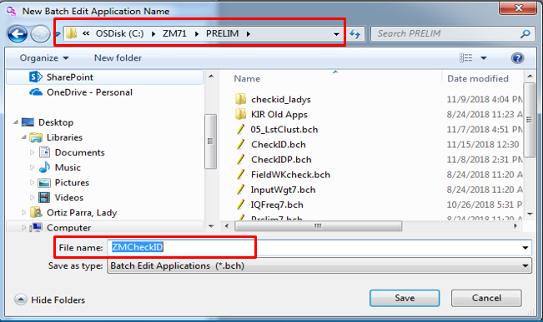Set the path where you want your application to be created as “C:\cc81\PRELIM”
* On the file name field, write the name of the new application you would like to create “ccCheckID” and click the “Save” bottom.

Note: The application name should be the same as the one you just renamed “ccCheckID” (without extension*). This is to allow CSPro to include the logic and messages defined on “lstClust” as part of the new application.*

* 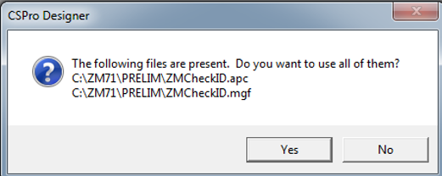CSPro will ask you if you want to use the “ccCheckID.apc” and “ccCheckID.mgf”. Click “Yes”.
* Browse to add the main dictionary as “ccIQ81.DCF”
* Browse to add the external dictionary as “CONTROL.DCF”
* 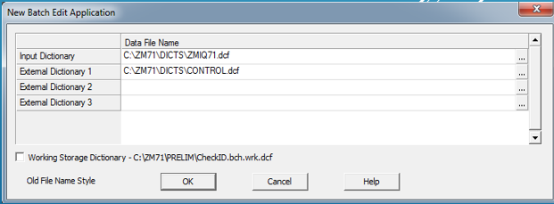Click “OK”

Once the CheckID application has been set, there will be a big number of adjustments that need to be done like in order to compile the application successfully.

# 11. « Others » responses

DHS questionnaires include for almost all the closed-ended questions, the category “Other: specify”. This is because sometimes answers given by respondents during the enumeration cannot easily be classified under existing categories. To give the interviewers the ability to enter these responses in the questionnaires, the “others, specify” category is used. After the data collection is complete and all the data has been received and edited, the processing of the “other responses” analysis can begin.

The reclassification of the “others” is somewhat complex, but its main objectives are to reclassify under an existing category and/or to create a new category if the frequency represents 2%-5% or more of the valid answers.

With an experimental survey or when new questions are added to a well-tested questionnaire and not all possible responses to these questions have been detected during the pre-test, the quantity of the “other” answers can be considerable. In some cases, it may be worthwhile to create new categories after completion of fieldwork and recode the written responses into newly created categories. However, this should be done only on rare occasions where a significant number of responses can be recoded, generally a minimum of 5% of the N of valid responses. Any decision to create new categories should first be discussed with the survey manager and survey director.

The “others” processing requires few steps that are summarized in the following table. This table lists all applications (in order of execution), as well as the batch files to invoke them and the naming convention for the input and output files associated with each step. The standard version of all files listed can be found in SharePoint under the data processing standard application in the sub-folder “\Others”.

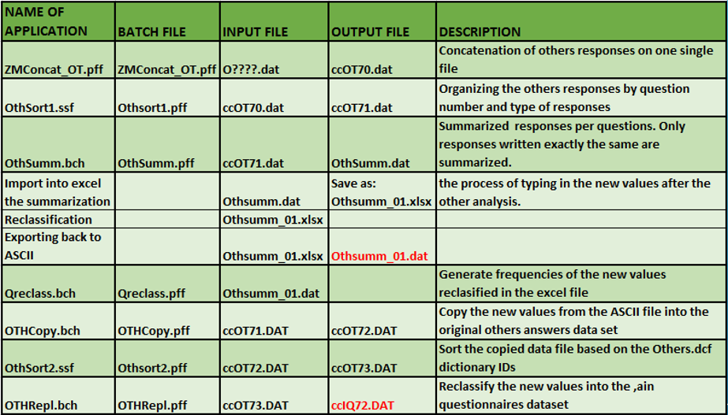

## 11.1 Others Data Concatenation

To concatenate the “others” responses follow the steps in point 6 above.

### 11.1.1 Others Concatenate PFF File

***Application name***: ccConcat_OT.Pff

Input data file: O????.dat

Output data file: ccOT70.DAT

***Listing report:*** ccconcat_OT.lst

***Note****: it’s highly recommended to always check the report file to make sure that the output data file contains all the expected files*.

### 11.1.2 Sorting (1) “Others” Data

The standard applications for sorting the “others” data file can be found under the \OTHERS subfolder. The “others” data should be sorted in two different stages: 1) after data concatenations “OTHSort1.ssf” and 2) before adding the new categories resulting of the “others” analysis into the main questionnaire data “OTHSort2.ssf” (application OTHREPL).

**OTHSort1 application**

The key variables for sorting the “others” responses are the question number “OTHQues” and the other responses “OTHRESP”.

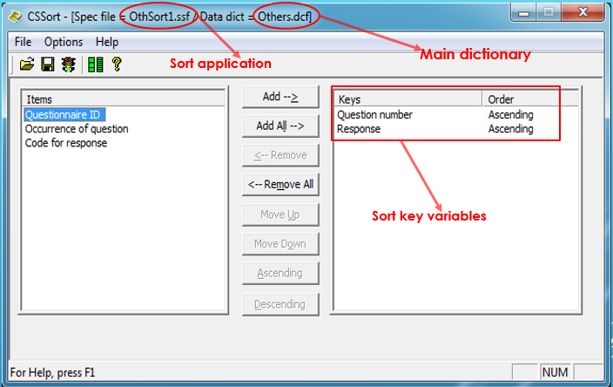

**OTHSort1 PFF executable file**

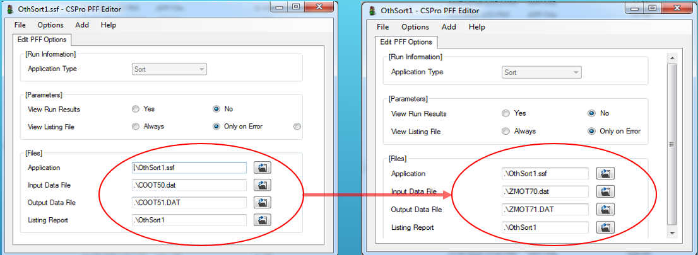The sort application can run thru CSPro interface or by just double-clicking on the .pff file. The standard .pff for sorting is set using Colombia DHS phase 5. Before executing the sort application, open the OTHSort1.pff with a text editor or with CSPro PFF editor and change the input and out data file to the country specific.

### 11.1.3 Summarization of “Others” Responses (OTHSUMM.APP)

The OTHSUMM application generates a summary of all the responses found on the concatenated and sorted data file “ccOT81.DAT”. The summarization will be printed in the output file, called OTHSUMM.DAT. The dictionary defining this data file is XOTHERS.DCF, with the questionnaire ID defined by the question number of the other answer (called XOTHQUES) and a sequential number (XOTHNUM), assigned by the OTHSUMM application. For each question number, all identical responses are assigned one sequential number and thus appear only once in OTHSUMM.DAT.

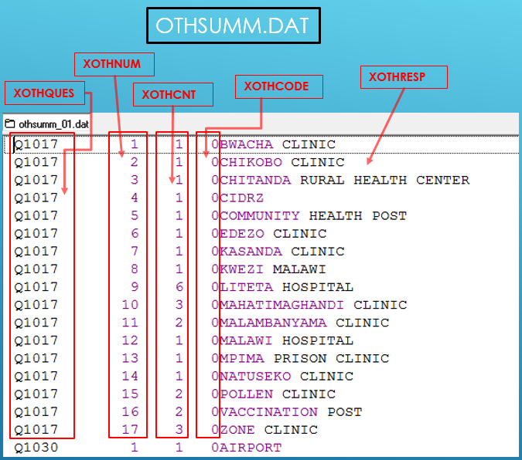Another variable (XOTHCNT) indicates the number of times this exact response was given for this question number. Also included in XOTHERS.DCF are XOTHCODE, used to assign possible recoding (but the variable will be initialized to 0 for all cases after running OTHSUMM) and XOTHRESP (which is the textual response entered by the keyers). Note that the occurrence (OTHOCC) as used in the “getother” function is not taken into account. All answers are summarized irrespective of the occurrence!

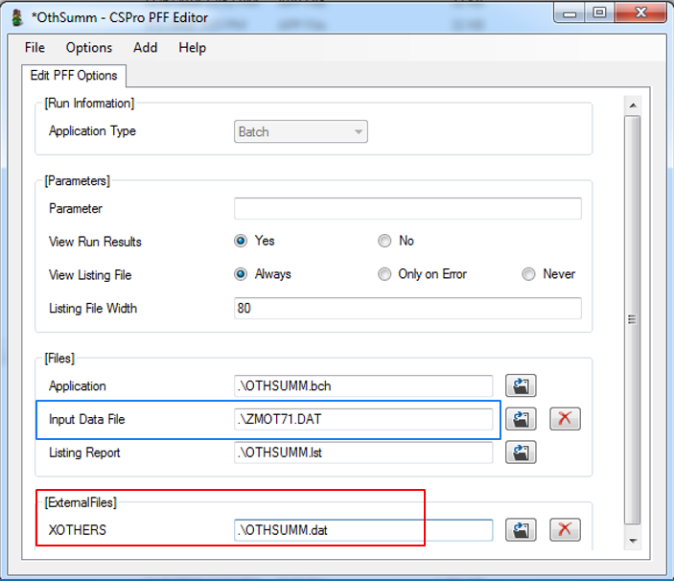No changes are needed to OTHSUMM.APP. This application is executed by OTHSUMM.BCH or by double-clicking on the OTHSUMM.PFF, *after adjusting the name of the input and output data files “.pff”.*

### 11.1.4 Exporting “OTHSUMM.DAT” into Excel

The summarized responses OTHSUMM.DAT should be exported to excel for recoding purposes. The Excel file should be provided to the central office DP staff to start the “others” responses analysis. Usually, a team of people by area of expertise is often involved in this process. They should be very knowledgeable about the (purpose of the) questionnaires. If the answers are entered using local languages then the coder should be able to read these languages. Therefore, several people are often assigned to work on this task together. *Ideally, the survey director and the country monitor should be involved in this task*.

Some general guidelines on recoding “other” answers are:

* All answers that can be recoded into existing categories (codes) should be recoded. If there are many of these cases, then it was not made clear enough during the training of the enumerators that if possible existing codes can be used they should be used.
* Special attention is needed for the recoding of compounded codes (variables with a unit and number part). The assigned new code has to include an indication of the unit.
* Answers given to questions with alphanumeric categories should be transformed into numeric categories. Thus, the new codes will range from 1 to 26, for each letter of the alphabet.
* Categories used in the first two columns of the calendar, generally use numbers and letters. In this case, assign “A” the value 10, “B” the value 11, etc.
* New categories can be assigned, but this should only be done when there are a considerable number of cases. It depends on the type of survey in order to determine how many answers of the same type merit a category. For exploratory or in-depth survey the minimum number selected is often between 75 and 100 cases. For a standard MEASURE/DHS questionnaire, the minimum is set higher, usually in the range of 2 to 5 percent of valid answers. Thus, if there are 6000 responses to a question, this would indicate a range somewhere between 120 and 300 questionnaires.
* When the new code to be used is “0”, then this has to initially be given a different code, since “0” is used to mark that there is no change necessary. The new code has then to be recoded to “0” in the OTHREPL application (see step ???).
* *An electronic or paper copy of the questionnaires should be provided to the staff that will be analyzing and reclassifying the others responses*.

**Importing into excel**

The OTHSUMM.dat file should be imported into Excel to facilitate the reclassification of the responses. Instruction should be given on how to proceed and the standard recoding rules to follow. The staff in charge of this process will enter the new values manually. All suggested recoding values should be review carefully by the data processing specialist.

* Open a new Excel spreadsheet
* Click on “File” 🡪 “Open”
* Go to the subfolder where the OTHSUMM.DAT is: typically, C:\cc81\OTHERS and enter the “file name”

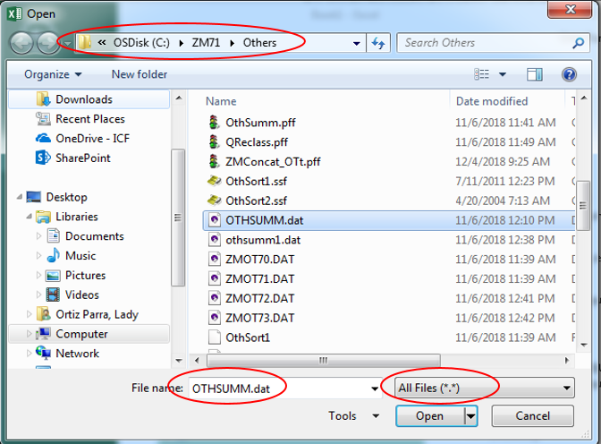

* Click “Open”
* The Excel Text Wizard screen will open
* 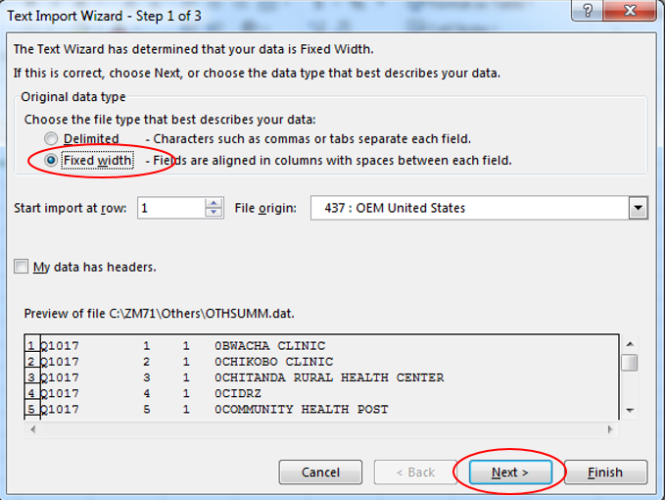Wizard step 1: Make sure that the “Fix Width” bottom is selected and click “Next”
* 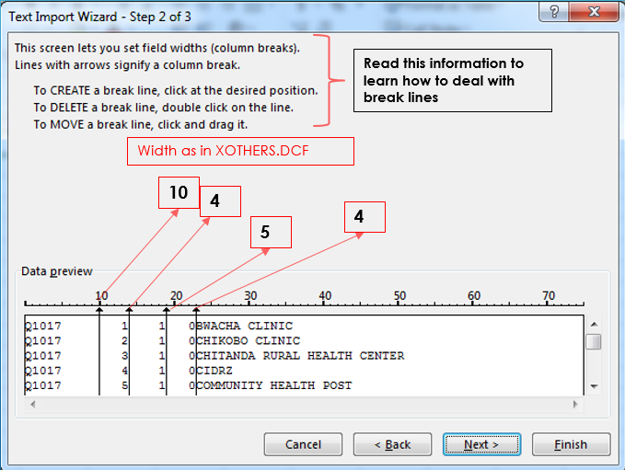Wizard step 2: Set the width of each field as define on the XOTHERS.DCF and click “Next”
* 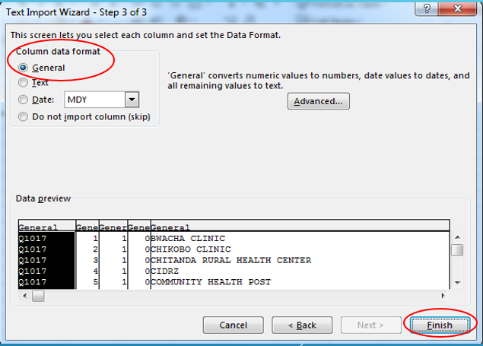Wizard step 3: Set the data format as “General”
* Click “Finish” an Excel will import the “others” responses into a spreadsheet.

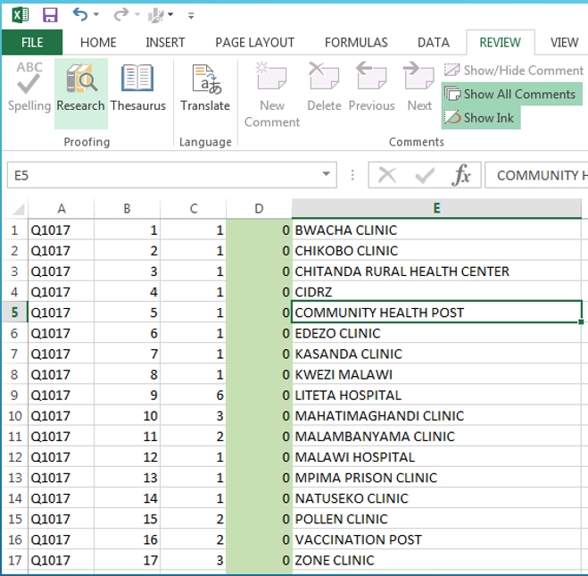

* To finalized this spreadsheet, all columns should be locked to avoid any modification to the original text of the “others” responses by the staff in charge of analyzing and reclassifying. Also, change the color of the column “D” as an indication that this will be the only columns where categories will be entered (if needed).
* To locked, do right click on column A, B, C and E, select “Format cell” and click on the “Protection tab” and select the box “Locked”.
* Do the same thing on column D but unselect the box “Locked”
* On the top excel menu, select the tab “Review” and click on the icon for “Protect Sheet”
* After protecting the columns, Save the file as “.xls”.

**Exporting Excel back to ASCII format**

After the central office has finished the “other” analysis and all the possible new values have been entered into the excel file OTHSUMM.xlsx (see the previous step), the DP manager should export the updated excel file to ASCII format.

* Open the Excel file OTHSUMM.xlsx
* Set the width of each column to match the variables length defined in the dictionary XOTHERS.DCF: Column A (10), Column B (4), Column C (5) Column D (4) and Column E (80).

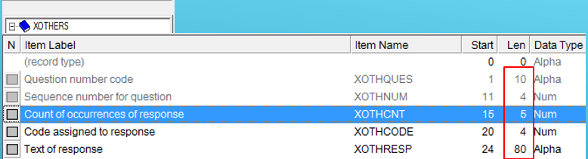

* + 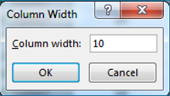Right click on the head label of each column (A, B, C, D, E)
  + Select “Column width”
  + Enter the expected width for each column
* Click on “File” 🡪 “Save”
* Again Click “File”
* Select “Save as”
* On the “save as” screen:
  + Select the destination (path) where the file will be saved “C:\cc81\OTHERS”
  + Select the “Save as type” as -space delimited *.prn-
  + Type the file name of the output data file
  + Click “Save”
  + If the output data file name already exists, Excel will ask you if you want to replace it.

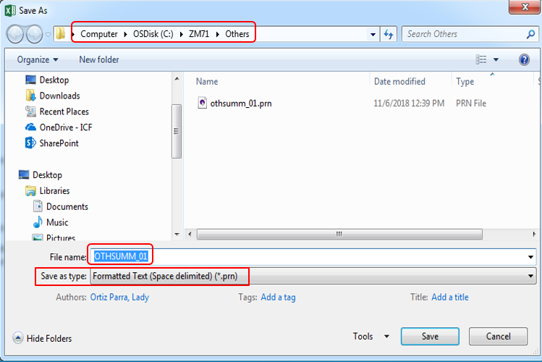

* 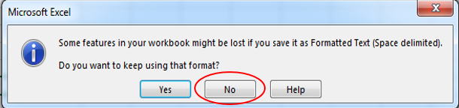The next screen will popup asking if you want to keep using the .prn format. Click “NO”. Then Click “Cancel” on the next screen.

### 11.1.5 Running Frequencies to Check “New Values” (QReclass)

The frequency application QReclass is very useful for reviewing the recoding of the new values. It’s recommended to run this application to make sure that new values are within the value range defined in the questionnaires for each question. It is also very helpful to set the logic of the OTHRepl application, which is the last step of the “others” reclassification.

***Note:*** *Out of range values should be fixed on the spreadsheet and all the steps from the “exporting into ASCII to OTHRepl should be repeated.*

This application does not need to be modified just change the input data file on the “.pff” file. All frequencies will be listed on the “.lst” file.

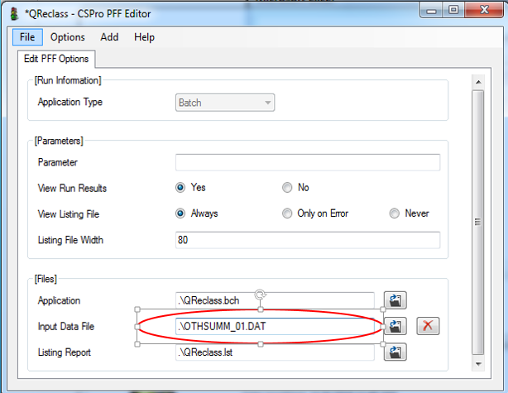

### 11.1.6 Copying the “New Values” Back to the Original “Others” (OTHCOPY)

When the new values for the recoded “other” answers have been reviewed thru the frequencies and cleanup, use the OTHCOPY application to copy the contents of the updated OTHSUMM_01.DAT file into the file with the original “other” answers (ccOT81.DAT). The output file for this application should be named ccOT72.DAT.

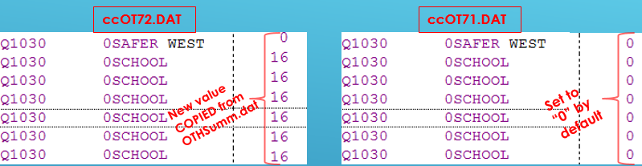No adjustments are necessary to the OTHCOPY application; just in “.pff” file, the name of the input and output data file should be changed. To execute the OTHCOPY applications use OTHCOPY.BCH or OTHCOPY.PFF

### 11.1.7 Sort (2) – OTHSort2.ssf

The updated “other” answers data file ccOT72.DAT should be sorted based on the questionnaire identification of the original OTHERS dictionary. Again, use the SORT utility in CSPro to sort ccOT72.DAT by Questionnaire ID (OTHID). The input file is ccOT72.DAT and the output file is ccOT73.DAT.

**OTHSort2 PFF executable file**

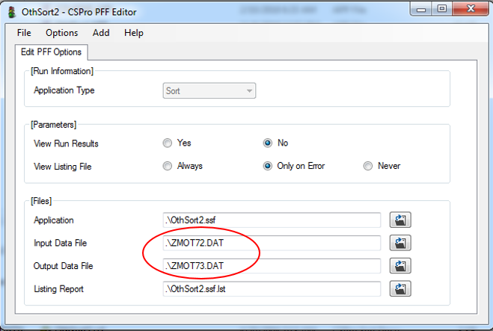The sort application can be run thru CSPro interface or by just double-clicking on the .pff file. Before executing the sort application, open the OTHSort2.pff with a text editor or with CSPro PFF editor and change the input and out data file to the country specific.

### 11.1.8 Replace “Others” Responses New Values into the Main Questionnaires Dataset (OTHRepl)

The final stage in the "other answers" process is to run the OTHREPL application, with the concatenated main data file <ccIQ81.DAT> and ccOT73.DAT as inputs. The output from this application is a new data file with the codes for the "others" answers added <ccIQ872.DAT>, and any necessary changes made to the values of other questions (for example, where the newly assigned category has been changed to a value which would have caused a skip over certain questions in the original data entry process).

Many adjustments are often necessary to the OTHREPL application since the skipping pattern might be quite different from the standard. The standard OTHREPL.APP can be found in SharePoint under the DP standard project and OTHERS subfolder. This application should be adjusted with AtoQ to reflect the country-specific naming conventions and should then be checked carefully for necessary modification.

Use the frequencies generated with QREClass to make changes only on the questions were new values were recoded. Check that the categories listed for every question number in QRECLASS.lst are indeed within the range expected. If this is not the case, then a mistake has been made during the updating of the OTHSUMM.DAT excel file (step ???).

The output of the OTHREPL application (OTHREPL.LST) provides a listing of all assignments to variables made by the OTHREPL as a result of recoded responses. This listing should be inspected carefully.

Do not forget that when the other answers process is complete the data dictionary must be updated to reflect any new value set and altered ranges which have been entered into the data file as a result of the recodes from the “other” responses.

*Do not forget to update the dictionary value set to reflect additional categories added due to high frequencies. New categories should also be documented in the final recode document.*

# 12. Calculation of Sample Weight

The sampler specialist assigned to a survey will provide to the DP specialist the Excel spreadsheet with the formulas to calculate the weights. The sampler will prepare the spreadsheet after completion of fieldwork and ideally before the DP final trip -*This worksheet should be supplied to the data processing specialist by the sampling specialist prior to the final trip*. Depending on the sample design, the spreadsheet will include weights for all households, women and/or men. If the male questionnaire WILL BE applied to a subsample of the selected households, a household’s weight for the subsample should also be part of the spreadsheet. For domestic violence’s weight, the sampler will provide a separate spreadsheet, if the DV module is part of the survey.

The weight spreadsheet is based on formulas only that needs specific input data coming from the main questionnaire data file. The DP specialist needs to run several cross-tabulations of some geo-variables, also known as sample domains, (e.g. cluster, rural/urban area, region or a combination of these) according to the final result of the household and individual questionnaires (QHRESULT / QRESULT), *de facto* women and *de facto* men. The application that generates the input data tables, including domestic violence, can be found under the subfolder \prelim, named “InputWgt7”. *To keep your main CS folder organized, it’s recommended to create a subfolder named “Weight” to keep all the files related to weight calculation.*

In order to calculate the weights correctly, it is important that the re-coding of the “others” responses of the result variables in the household (QHRESULT) and individual questionnaires (QRESULT) has been completed. Thus, either the re-coding of all the “others” responses have to be completed or “other” answers of the result variables have to be dealt with separately. In the last scenario, the coding will have to be carried out before the rest of the “other” answers. Remember, that only answers that fit existing categories should be recoded, but in general, very few “other” responses should remain after the re-coding of those 2 variables.

Once a response table or listing has been generated, it should be transferred to the Excel worksheet used to calculate the weights. Usually, calculation of the weights is a simple matter of adding the response numbers to the spreadsheet. Check that the weighted totals number of cases in the spreadsheet match the unweighted number of completed responses for the sample.

Typically, the Excel spreadsheet comprises four worksheets named: Input, WomStdWgt, MenStdWgt, and Summary.

***“Input” worksheets*** is where the information from sample domains variables (cross-tabulation) is input. It’s recommended that the layout of the input table generated using the application InputWgt7 has the same order as in the “input” worksheet. This will facilitate the cut and paste of input data into this worksheet.

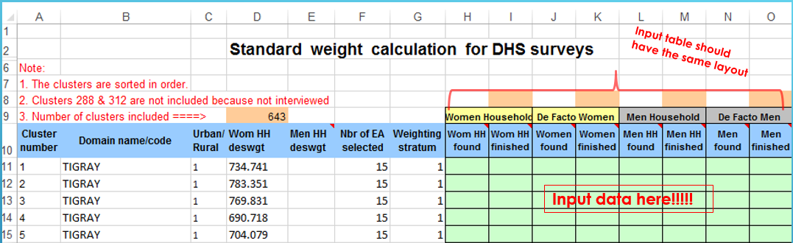

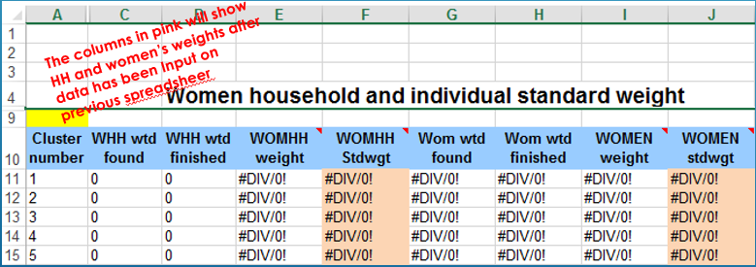***“WomStdWgt” worksheet***. The women standard weight worksheet will produce the weights for all households and women. The spreadsheet formulas will recalculate after the input data has been entered on the “input” worksheet.

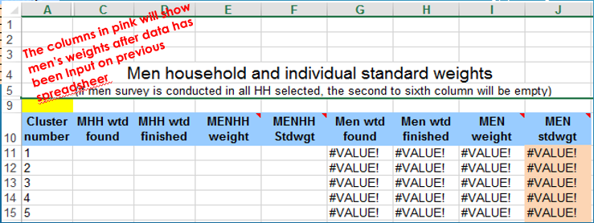***“MemStdWgt” worksheet***. The men standard weight worksheet will produce the weights for the men sample or subsample. The spreadsheet formulas will recalculate after the input data has been entered on the “input” worksheet.

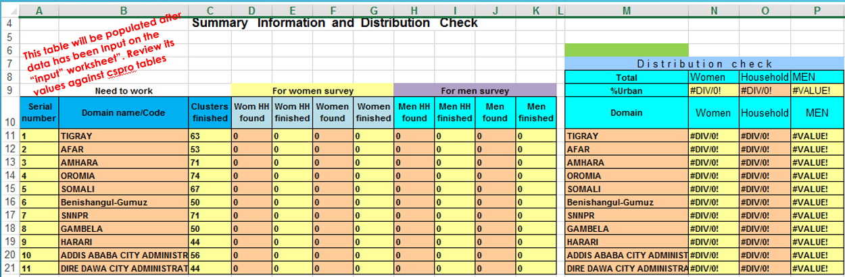***“Summary” worksheet*** will show the distribution of all the cases in each survey domain. The input table’s application includes a similar table that should be double check against the values in this worksheet. If any discrepancies between the two tables, all the process related to the calculation of the weight should be reviewed and adjusted until no discrepancies are found.

After the weights have been calculated by the Excel spreadsheet, the weights’ values should be exported to ASCII format to be used as a lookup table in the imputation application. A new worksheet should be added to the weight’s spreadsheet that can be called “FinalWeight”. From the “input” worksheet copy the flowing column to “FinalWeight” worksheet: cluster number, region, urban/rural and the stratification. From the “WomStdWgt” worksheet copy the household and women’s weight, and from the “MenStdWgt” worksheet copy the men’s weight. *Only copy the values, NO the formulas.*

## 12.1 Exporting “FinalWeight” Worksheet into ASCII Format

Before exporting the “finalweight” worksheet to ASCII:

**Weights dictionary**

* Go to the subfolder \DCFTS and open the dictionary “Weights.dcf”
* Delete the existing variables that don’t need (if any)
* Add new variables: region, urban/rural, stratification and any other, if necessary. *Even though adding the region and urban/rural variables is not mandatory, it’s highly recommended. This variable can be used to double check that the domains variables in the main data match the variables provided by the sampler. Any discrepancy should be fixed before the final weights are produced. Those three variables can be found on the “input” worksheet.*

**“FinalWeights” worksheet**

* Make sure that columns variables are in the same order as in the weights-dictionary.
* Set the width of each column the same size as defined in the weight-dictionary (in case, the “save as” command is to create the ASCII file).
* 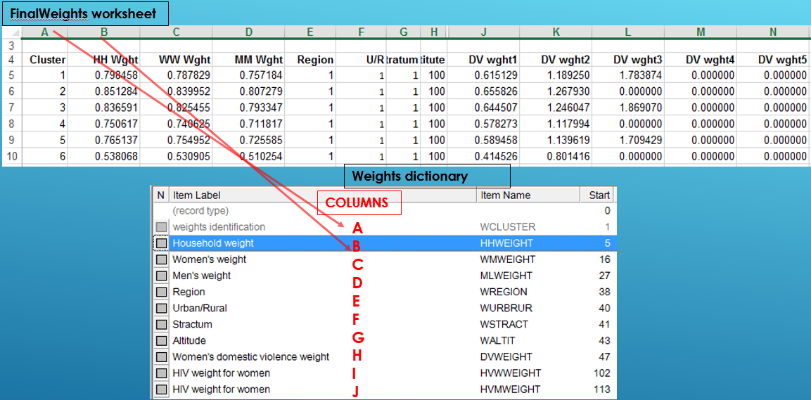The standard weight dictionary does not have decimal point for the weight variables. Keep in mind that if the CSPro-to-Excel tools will be used the decimal point should be removed from the worksheet. The facts are that both, the dictionary and the worksheet should have the same format: both with decimals or both without decimals.

There are 2 ways of exporting the worksheet to ASCII.

1. By using “Save As” command from Excel
   * Select the path where the file will be saved
   * Enter the name of the file
   * Select the “type of save as” as space delimited “.prn”

*Again, if this mode will be used, make sure that the order of the columns in the worksheet is in line with the weight dictionary. More importantly, make sure that the width of each column is also as defined in the dictionary. This is to avoid doing any manual changes to the asci file*.

1. By using the “Excel-to-CSPro” tools
   * Open CSPro and select “tools”
   * Click on “Excel-to CSPro”
   * The screen below will popup

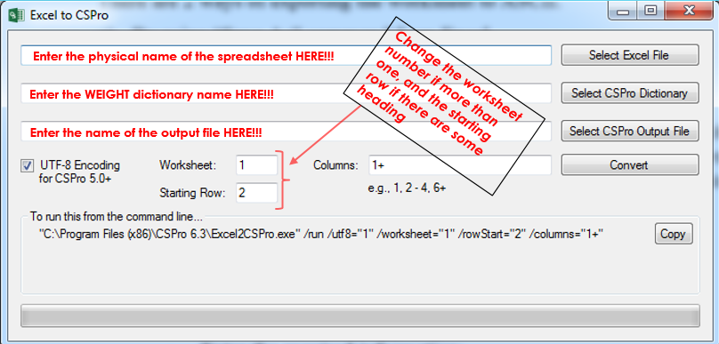

* + 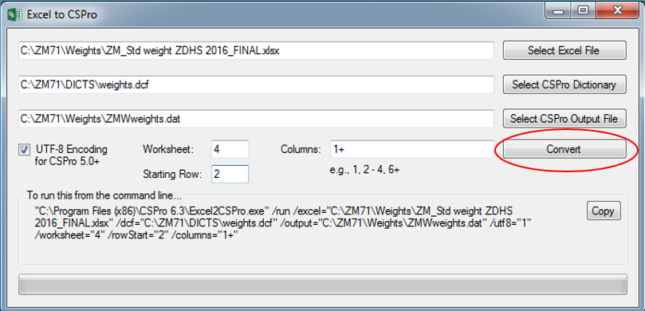Enter the required information and click “Convert”

The usual way to add the calculated weights to the questionnaire main data file is by using the weight dictionary as an external file and the weight data (imported from excel) as a lookup table in the imputation program. The weights values obtained from the worksheet should be multiplied by 1000000 before being added to the data file (there should be no decimal point in the data file).

Note: The HIV weight is calculated differently. The procedure to produce the HIV weights will be explained as a separate topic in this document.

In the imputation program, the weights for incomplete household questionnaires, as well as incomplete individual and male questionnaires, should be set to 0. Remember also to set the weight variable for all *non de facto* individual and male to 0.

Once the weights have been added to the data file, the distributions of background characteristics such as age, region, marital status, and urban-rural location, should be run for both weighted and unweighted data. Tables 2 of the KIR tables or 3.1 of the final tabulations (chapter 3) can also be used for this purpose. The total number of complete interviews for households, female and male respondents should be the same for both weighted and unweighted distributions if the weights are correctly calculated. If they do not match, review all programs associated with the weight calculation to determine where the error lies.

The distributions for background characteristics, together with the final weight (Excel spreadsheet) should be sent to the sampler specialist for its review. Generally, the weighted and unweighted distributions should not vary greatly for nongeographic factors such as age and marital status. If a previous DHS survey was carried out in the country, check that the overall percentage distributions for regions and urban-rural are comparable with those from the earlier survey, particularly for weighted data.

# 13. Secondary Editing and/or Imputation (ccImpute)

The secondary editing (SE) process is part of the central office menu system with the main purpose of checking inconsistent information in the data collected. These discrepancies can be because the respondents gave inconsistent information and/or typos from the enumerators during data capture. There is a secondary editing manual with the standard guidelines used by the DHS program to resolve, if necessary, the inconsistencies detected by the SE application. All clusters should be secondary edited by the central office staff, and this process should be implemented concurrently with the fieldwork. Therefore, secondary editing should end days after fieldwork. Before a closing trip, the central office should complete the SE for all clusters.

SE program should also be run as part of the closing activities after all the data have been concatenated into one single hierarchical data file, sorted, and the “others responses” have been reclassified. For the closing trip, the SE application is also used to impute the dates of key events, to calculate the century month code (CMC), calculate century days code (CDC) and some flags variables. In addition, the weights factors variables are populated as part of the imputation application.

Overall, these are the main tasks of this application:

* To list/review the remaining SE messages and made the necessary adjustments.
* To list/review the messages restricted by the working variable “run1”. Messages restricted by “run1” will only be shown once, independently if the inconsistency is resolved or not. It is the responsibility of the DP specialist to review all of them as part of the final visit and make changes only if necessary.
* To impute the “date” variables when the information is partially or totally missing or unknown.
* To calculate the CMC and the CDC of all “date” variables collected.
* To calculate some flag variable with the imputation final outcome.
* To populate the weight factors variables.

The SE program that will be used at the closing stage is the same program used by the central office, located under the \central subfolder, with the difference that this new application will use the hierarchical and reformatted dictionary “ccIQ81.DCF”. SE application can be switched to imputation mode by setting the value of the working variable “doimp” to “1”.

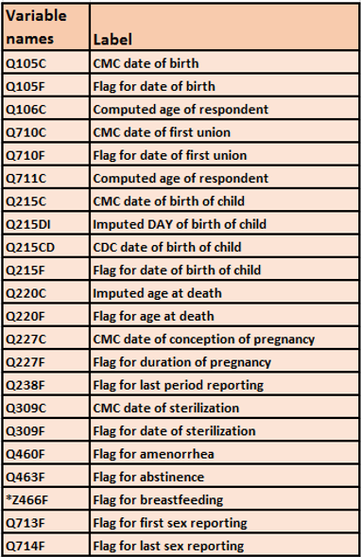The next table includes all the variables that will be populated when this application is set for imputing.

***Note:*** *After the application is run on imputation mode, it’s recommended to run frequencies to check that each variable listed on this table has been populated with no errors.*

## 13.1 Creating “ccImpute” Application

There are two SE applications, one for the household and biomarkers questionnaires “ccHHEdit7” and another for the individuals –women and/or men- “ccINEdit7” that need to be combined in one new application named “ccImpute”. Because CSPro does not have a tool that allows combining these two batch applications, this process will be done manually and will require a lot of alterations in order to compile successfully.

To combine the two applications, first, a new batch application should be created using the individual SE logics “ccINEdit7”. Second, the households SE logic should be cut and paste into the new application under the right “proc” of the application.

The main steps to create and combine the SE programs are:

* Copy from the \Central subfolder the file called “ccINEdit7.app” into the \Prelim subfolder.
* Copy from the \Central subfolder the file called “TotEdit7.msg” into the \Prelim subfolder
* Rename the file “ccINEdit7.app” 🡺 “ccImpute.apc”
* Rename the file “TotEdit7.msg ” 🡺 “ccImpute.msg”
* From CSPro interface click on “File >> New >> Batch Edit Application”
* Set the path where you want this application to be created as “C:\cc81\PRELIM”
* On the file-name field, write the name of the new application you would like to create “ccImpute” and click the Save bottom.

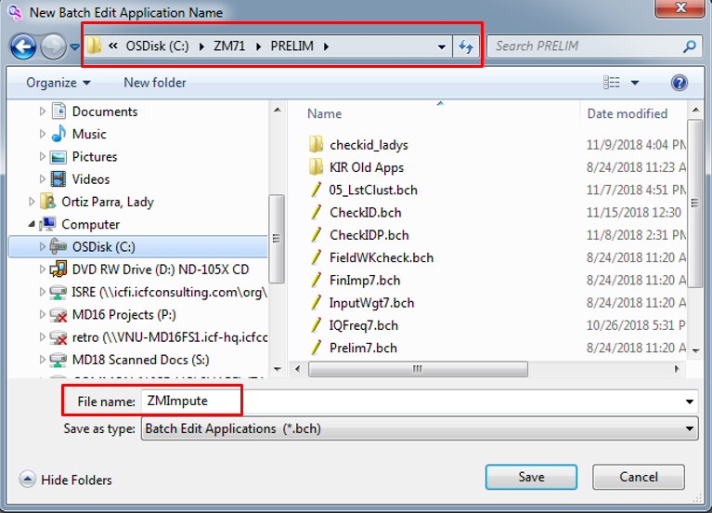

*The application name should have the same as the one renamed on previous point: “ccImpute” (without extension). This is in order for CSPro to use the logic of the “ccImpute.apc” as part of the new application; as well as the “ccImpute.msg” file.*

* 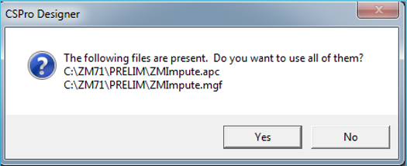CSPro will ask you if you want to use the “ccImpute.apc” and “ccImpute.msg”.
* Click “Yes”.
* Browse to add dictionaries:
  + the main dictionary as “ccIQ81.DCF”
  + 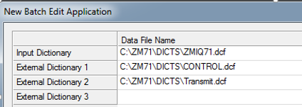the external dictionary “CONTROL.DCF”
  + the external dictionary “TRANSMIT.DCF”
  + the external dictionary FIELDWKQ.DCF”
* Click “OK”
* 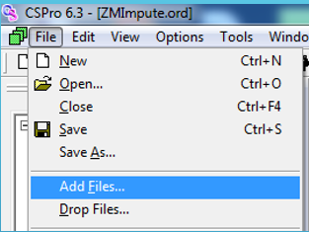CSPro will create/open the application “ccImpute”
* Click on “File” and select “Add file…”
* Browse to add the external logic file “DPEntry.app”
* 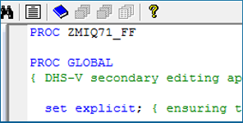Move the dictionary internal name “ccIQ81_FF” name to the right place
* Compile the application and fix all the warnings and errors until the compilation is successful.

1. ***Adding the household level SE logic (ccHHedit7)***
   * On separate screen, open the “*ccHHedit7* “
   * Cut and paste from “*ccHHedit7.apc”* the global level logics: arrays and functions. Do not copy the working variables yet. Be careful not to duplicate logic that already exist in the SE application for individuals.
   * Do the same with the dictionary level and household level.
   * Compile and debug all error messages and warnings.

*Note: Use the standard secondary editing application designed for paper-based survey as an example, in case it becomes difficult to successfully compile the application.*

1. ***Parameters for review and/or imputation***

The standard DHS editing and imputation application have two modes of operation: secondary editing and batch imputation. The mode of operation is determined by the working variable DOIMP, which is set to a value of ‘0’ for secondary editing, and ‘1’ for imputation. In secondary editing mode, the application checks a data file for various inconsistencies and outputs a detailed listing describing these inconsistencies. The listing is then used for secondary editing of the data.

*On the “preproc” of the dictionary level, there are two working variables (constant) used to set the mode of the application: Imputation and/or DP final review. They are set to “0” by default. Change the setting to “1” to activate the mode.*

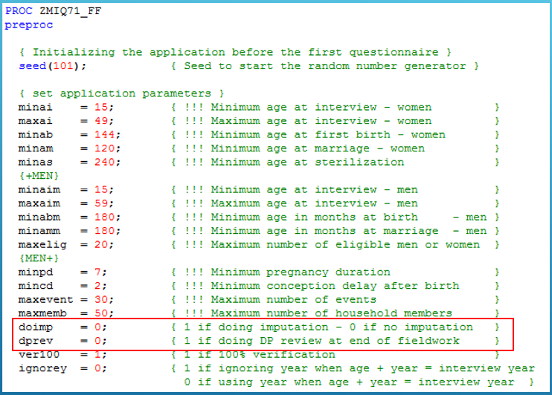

1. ***Enabling some logics***

The SE application includes some logic that should be enabled during the imputation process. Do a global search for the word “enable” on the application. Uncomment all of them and made the necessary adjustment for compilation.

*Note: the logic related to household, individual and domestic violence weight should be uncommented only when you have the weight’s dictionary and weight’s lookup data ready.*

## 13.2 Common SE Messages

After running the secondary editing program, a list of error messages will be opened in CSPro Text Viewer. Go to the end of the document to check the summary of all messages remaining. Verify first the messages where the frequency number is very high. Most likely this will be related to a syntax error. In general, all valid messages listed should be revisited and sorted out following the SE manual. There are some specific ones that should be corrected before imputation.

***“Error 1007”*** *System messages*. You should not expect many cases with this type of warning, but it can happen for several reasons. The example below shows one circumstance where the system error was generated because a household member was removed after the woman was interviewed.

At some point during data collection or secondary editing, a member of the household was deleted but the interviewer forgot to do the necessary adjustment on the birth history (Q219) or any other section affected by the line number. The screenshot below has 3 panels: a) error description, b) a birth history and c) a household schedule. The birth history table below shows that the household line number for child 06 is (Q219=07), however, the maximum number of members listed in the household is 6.

Solution: The name of the child can be used to identify the correct line number not only for child 06 but all kids with a valid line number in Q219. Children 04, 05 and 06 need to be corrected.

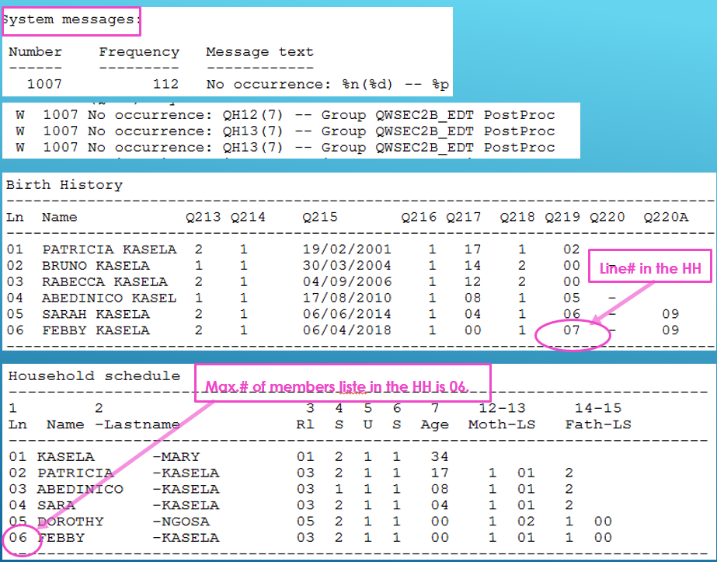

**0061 Son/daughter of the head of household but the head is not the father/mother of the member.** The household member has a relationship code “son or the daughter of the household head” and he/she is under the age of 17, however, the head of the household is not listed as the father or mother of the child.

2141 Child's sex in birth history (Q213), different from sex in the household (QH04)=n. The sex of the child given in the women's questionnaire (Q213) is different from the sex of the child in the household questionnaire (QH04).

2173 Child is (Q217) x years old in birth history but (QH07) y years in the household. The age of the child given in the women's questionnaire (Q217) is different from the age of the child in the household questionnaire (QH07).

*Note: The logic for this message should be modified to show cases where the age difference is 5 or more years. Those cases should be studied carefully and fixed if there is enough evidence of* errors. See the screenshot example below.



2182 Child n has a different mother in the household (QH13=n, mother’s line=n). According to the child's line number in the household schedule given in Q219, and referring to the mother's line number in question QH13 of the household schedule for that line, the mother's line number differs from the line number of the respondent (who is reporting the child as one of her children). See screenshot example below.

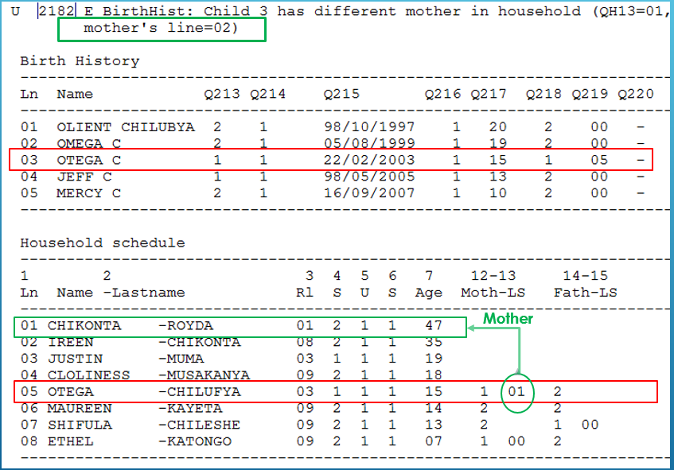

**2185 Child with HH #n not found in woman's birth history.** In the household schedule, a child was listed stating the respondent as his or her mother, but that child is not listed in the birth history of the respondent.

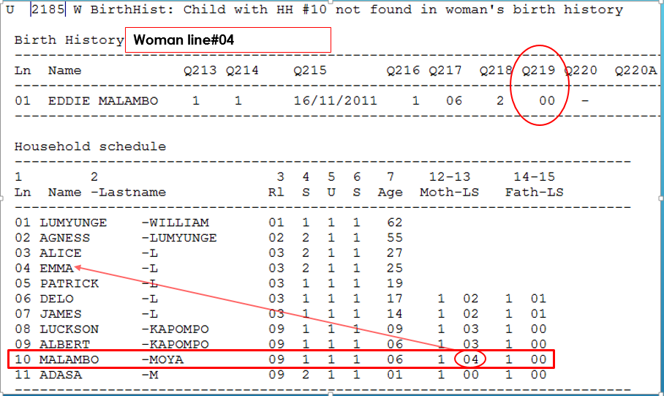

2186 Child n has no line number in the household (Q219=n), but the mother is de-jure member (QH05=n) and child lives with the mother (Q218=n). A child listed in the birth history is reported to live with the respondent according to Q218, and the respondent is a usual (*de jure*) member of the household according to QH05 in the household questionnaire, however, the child is not listed in the household schedule according to Q219.

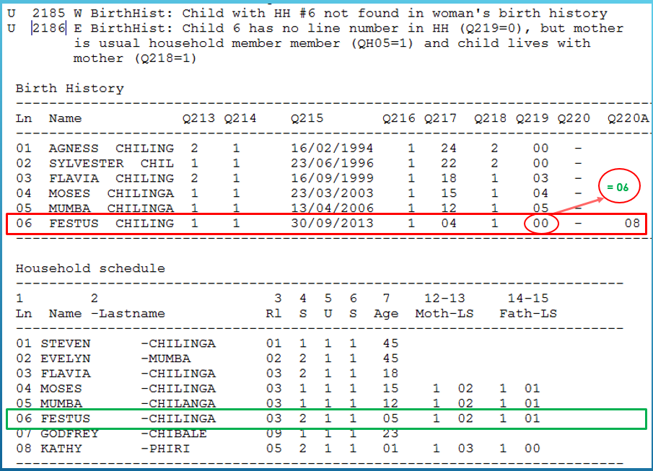

**4473 Vacc col n: Date of x (dd/mm/yyyy) is earlier than y (dd/mm/yyyy).** Dates for immunizations of a particular type (DPT or Polio) that are given in series must be consistent in their order, i.e., the date for the second and third immunizations in a series cannot be earlier than or on the same date as the first immunization, and so forth. See the example below.

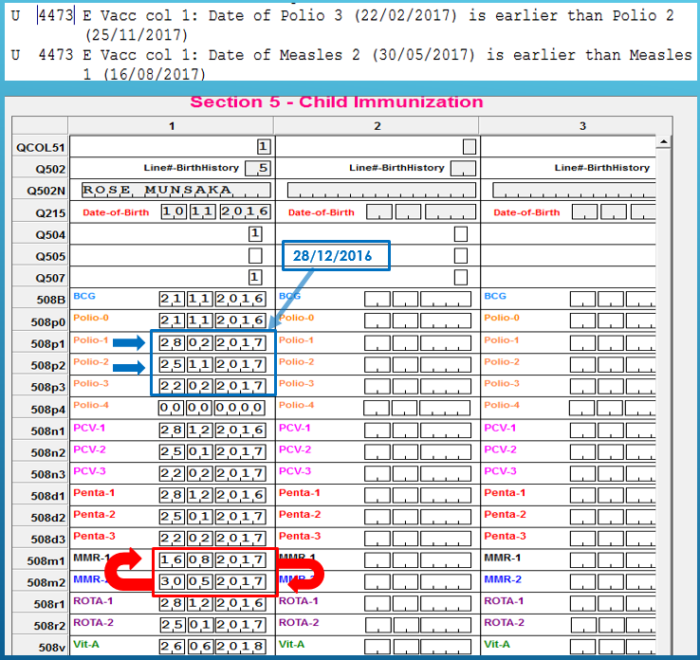*This error must be fixed but keep in mind that each case should be analyzed separately. The same solution should not be applied to all cases. For the case below, Measles vaccination should be switched. For Polio 1, I followed up the pattern of Penta and PCV.*

**9000 Siblings listed out of order.** This message should be fixed before running the imputation programs for maternal mortality. Please follow the SE manual guidelines.See one example below.

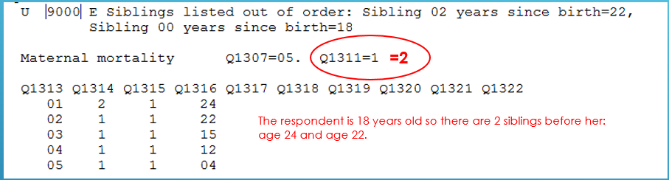

**9803 Calendar: Gestation length different from 9 months.** A birth in the birth history is reported as having a gestation length other than 9 months, that is, the code “B” is not preceded by 8 code "P"s.

Note: There will be many pregnancy cases where the gestation is 8 or 10, sometimes 11 months. However, extreme cases where the gestation length is questionable can be checked. To list just the extreme cases, adjust the logic for this message to show gestation length < 7 and > 10 months. Analyze each case and made corrections is necessary.

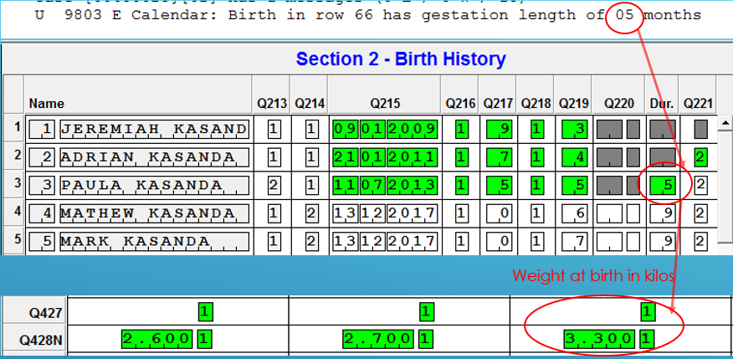*See the example below where the gestation length was 5 months. Weight at birth can be used to determine if this is a typo or the child was born prematurely.*

**9901 Interval between respondent’s date of birth and date of first union inconsistent:** The respondent's age at first union should not be less than a certain minimum, usually 10 years. A few women in each country will truly have married earlier than the minimum age, but most cases are incorrect and should be corrected.

*The example below shows a woman that was born on July 1982 and her date of marriage is October 1989. She was 7 years old when married. It’s very unlikely that a woman* married at age 7. *This case must be corrected by following the SE manual instruction.*

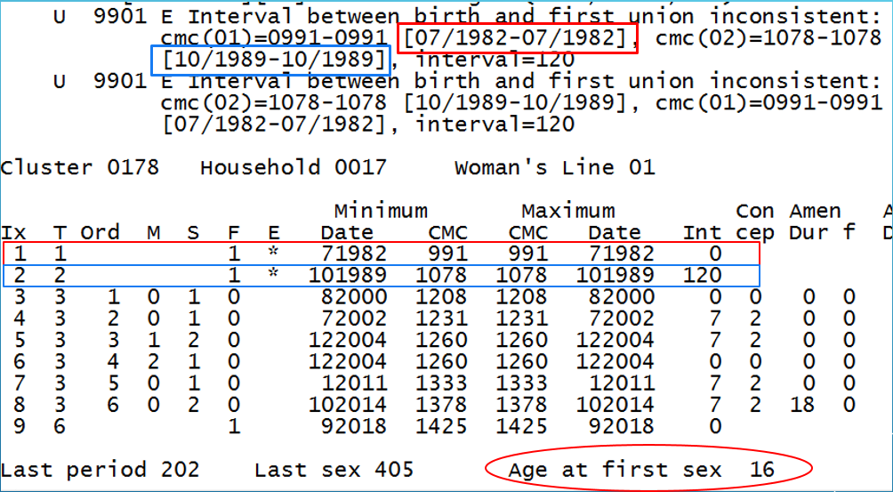

**9902 Interval between respondent’s date of birth and her first birth inconsistent:** A respondent's age at the birth of her first child cannot be less than a certain minimum age, usually 12 years. Typically, there are one or two cases in each country where the age at first birth is less than this minimum, but these are very unusual, and most occurrences of this message should be corrected.

*The screenshot below shows an example of error 9902. This woman was born in July 1978 and her first child was born when she was 4 years old, in July 1982. Clearly, this is an error that must be fixed by following the SE manual.*

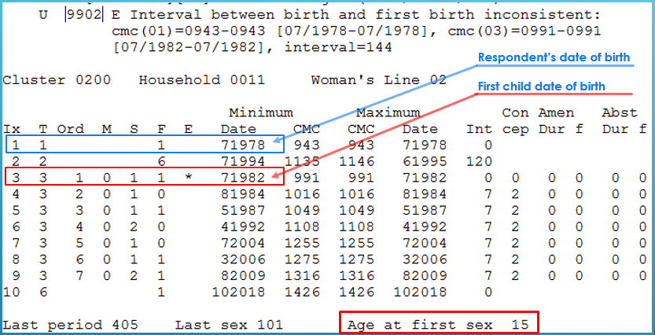

**9905 Interval between births inconsistent:** The interval between births (i.e., the number of months between the date of birth of one child and the date of birth of the next child) must be greater than or equal to 9 months for all births in the birth history.

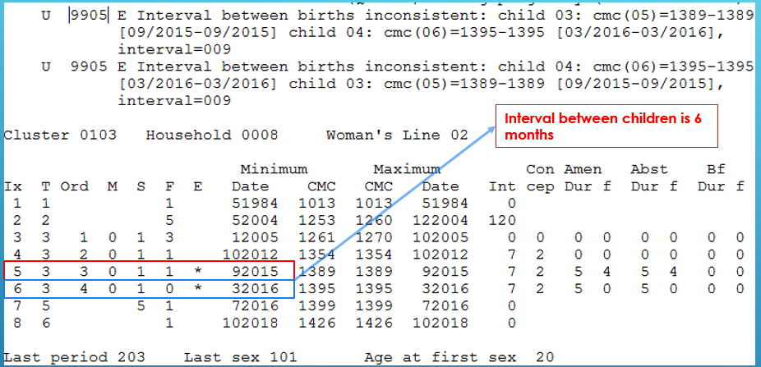

# 14. Nutrition Z-score (FinImp)

This application has two main purposes: a) the calculation of the standard deviation or Z-score of the height and weight measurements; b) Populating variables from the individual level to the household level. The main DHS dictionary has two hierarchical levels. Level 1 is for the household and biomarker questionnaires and level 2 is for women and men questionnaires. For all women and men with completed individual interview (level 2), some of their key information -date of birth, education, line number, etc. are assigned to the biomarker questionnaires using arrays. Essentially, those variables will be brought up to level 1.

This application adds the Z-scores variables for women AWPC1 through AWRI to record the ABSEC02. It furthermore adds the following background variables AWCMC (CMC date of birth of woman), AWFLG (Flag for CMC date of birth of woman), AWMBR (Imputed month of birth), AWYBR (Imputed year of birth), AWSMK (Respondent’s smoking practices), AWPRG (Respondent’s pregnancy status), AWMOS (Duration of current pregnancy in months), AWRES1 (Result of individual questionnaire), AWED1 (Highest level of education), AWED2 (Highest grade of education at level AWED1) and AWED3 (Highest education level as used in the tabulations for the preliminary and final reports). When information for these variables is available in the individual questionnaire then this is used instead available information in other parts of the household questionnaire. This because information from the individual questionnaire is considered of better quality, since it is always provided by the respondent and checked during secondary editing against other variables.

For men, the variables AMPC1 through AMRI are added to ABSEC03. The following background variables with information from the individual interview or household interview are also added: AMCMC, AMFLG, AMMBR, AMSMK, AMRESI, AMED1, AMED2 and AMED3.

For children, the variables ACPC1 through ACBI are added to ABSEC01. Also added to this section are ACCMC, ACFLG, ACMBR, ACYBR, ACED1, ACED2 and ACED3.

Lastly, three variables pertaining to the malaria module (when applicable) are added to the household schedule (AHSEC01): ML07I (Age corrected from the individual questionnaire), ML07F (Flag for age correction) and MLPREG (pregnancy status from individual questionnaire).

## 14.1 List of Working Variables in the “FinImp” Application

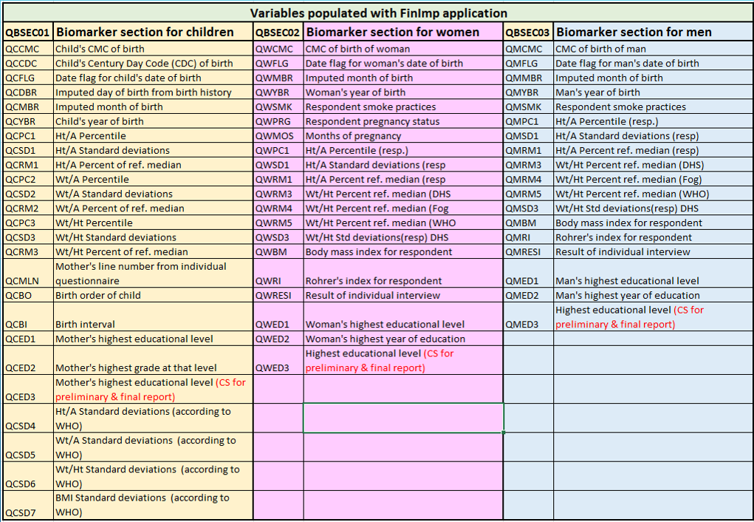***Note:*** *It’s highly recommended to run frequencies on the output data resulting of this application and check that there are not out of range values “@”, not default, and the not applicable number of cases are as expected.*

The ccFinImp7 application includes 3 arrays to store the women, men and birth history’s children variables that will be used in the upper level. The array dimensions are (50,15). No all 15 slots are used in case there is a need to add any other CS variable. The arrays definition are at the very beginning of the application: womvars(), menvars() and cldvars().

Again, review this application line by line all the way to the end. The logic for the array’s variables assignation is under the “PROC Individual”, at the end of the application. the screenshot below shows the arrays definition.

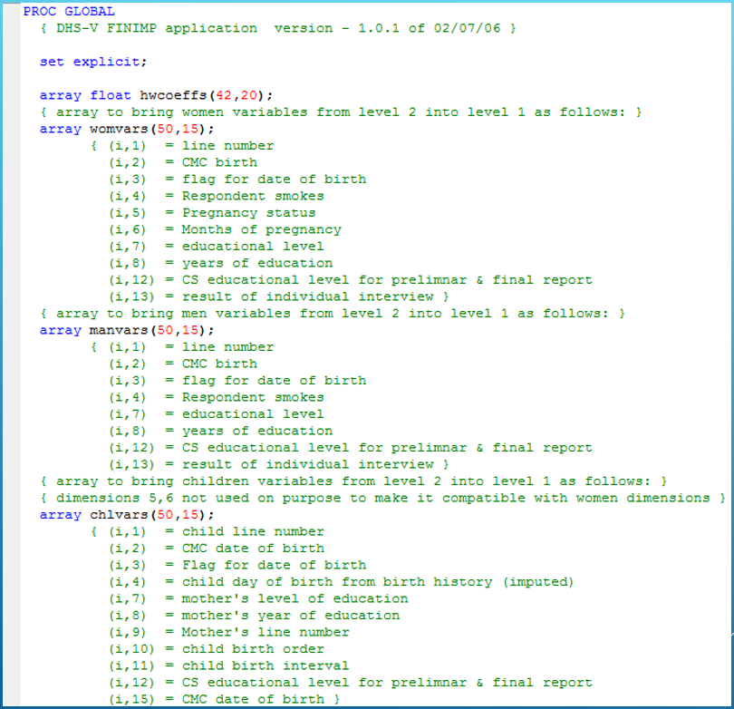

## 14.2 Converting “FinImp” Standard Application to Survey Specific

There are to mode of adjusting the FinImp application into CS specific application: a) creating a new application and, b) adjusting the existing application (using text editors).

### 14.2.1 Creating Survey Specific Application for FinImp

* Copy from the standard project folder \PRELIM the following files: FinImp.app, FinImp.msg, HWcoeff.dat and HWcoeff.dcf to your CS folder
* Rename FinImp7.msg 🡪 MZFinImp7.msg
* Open the utility A2Q and rename the application “FinImp7.app” using your CS “.in” file
* 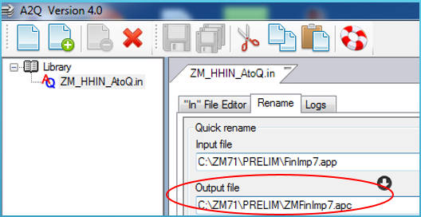The output file name should be the same as the message “.msg” and click “RUN”
* Close the A2Q application
* From CSPro, Click on “File” 🡪 “New…”
* Select “Batch Edit application”
* Change the path where the application should be saved to \PRELIM
* Add the name of the application (without extension) and click “Save”

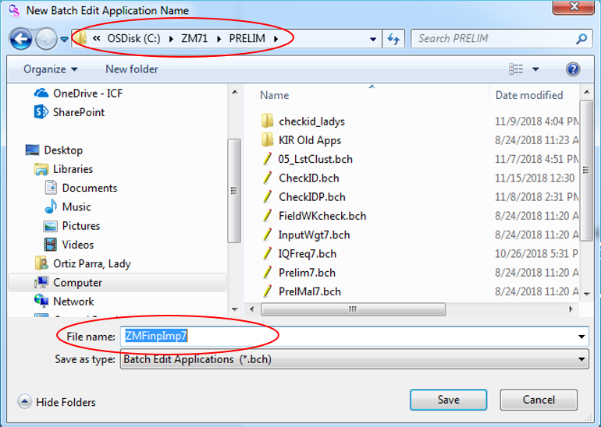

* CSPro will ask you if you want to use the files “.apc” and “.msg” found. Click “Yes”
* Browse to add the name of the main dictionary and any other external dictionary needed
* Click Ok
* Adjust the dictionary internal name in the logic
* Click the option “File” 🡪 “Add…”
* Browse … to enter the “external logic file” name “\Library\DPentry.app” and click Ok.
* Click the icon to compile and made the necessary adjustment until “compile successfully”

*Note: After compiling this application with no error, take the time to navigate thru the application and make sure that all the variables are well set. Also go to the end of the application and double check that variables from the individual level (women, birth history, and men) that will be brought up to the household level are also set properly. Pay special attention to the CS education variables that will be used in the preliminary and final report, as well as the use of cigarettes and individuals interview results).*

*Additionally, run frequency on the output dataset to verify that all the working variables on the BM records were populated with not errors and not special values as: default, @, not applicable.*

### 14.2.2 Adjusting “FINIMP” Application Using Text Editor

* Run AtoQ to the “FinImp.app” to adjust the standard variable names in the application to the names of the variables used in the CS dictionary.
* 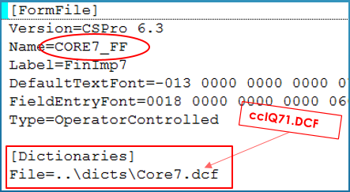Using a text editor, open the “FinImp.ord” file and change the name of the core dictionary to the country specific and save it.
* 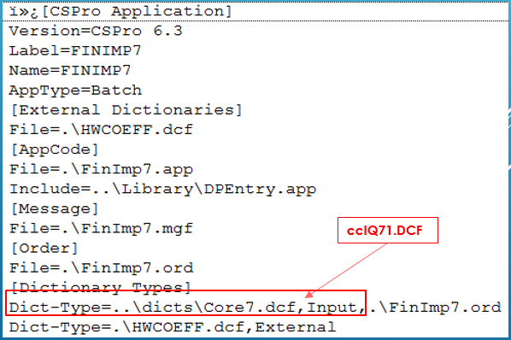Using a text editor, open the file “FinImp.bch” and also change the dictionary name and save it.
* After adjusting each file mentioned above, double click on the “WHOHWZ.bch” and CSPro will pop up some messages related to replacing the core dictionary variable by the new CS dictionary. Just click “Yes” until no more messages.
* Click the icon “Compile” for debugging until compile successfully.
* 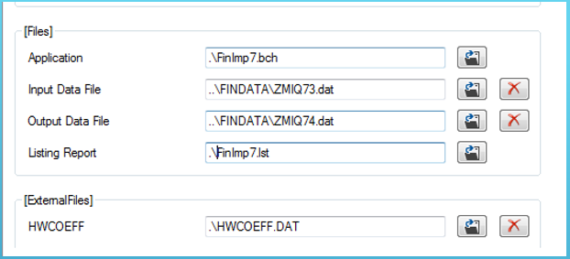To generate the .pff file, just run the application an enter the name of the input, output, and external data files *(this application uses the dictionary HWCoeff.dcf and the data HWCoeff.dat as external files)*:

### 14.2.3 Calculation of WHO Height-and-Weight Z-scores

During 2007, new cutoffs for the computation of the Z-scores for children were introduced by the World Health Organization (WHO). These Z-scores are added to the data file by means of the WHOHWZ application on SharePoint under the Standard Project, subfolder \Anthrop.

The four extra variables created are: ACSD4 (Height for Age standard deviations), ACSD5 (Weight for age standard deviations), ACSD6 (Weight for Height standard deviations) and ACSD7 (Body Mass Index standard deviations). Note that apart from the working dictionary (wprelim.DCF) this application uses three external dictionaries with three corresponding external data files (WFHlms, WFLlms, and LMSvars). All those files can be found under the \Anthrop subfolder.

WHOHWZ also creates a table showing the percentage of children under 5 years classified as malnourished according to the three anthropometric indices of nutritional status (Height-for-Age, Weight-for-Height and Weight-for-Age) according to background characteristics. This table is run on the raw-data file and can be included in the preliminary report. Thus, generating this table by running the standard application for the final report is no longer needed.

To adjust “WHOHWZ” application to country specific do:

* Run AtoQ to the “WHOHWZ.app” to adjust the standard variable names in the application to the names of the variables actually used in the CS dictionary.
* 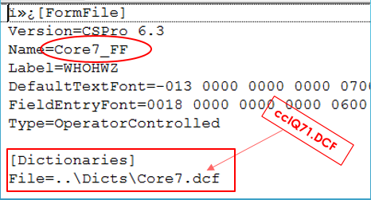Using a text editor, open the “WHOHWZ.ord” file and change the name of the core dictionary to the country specific.
* 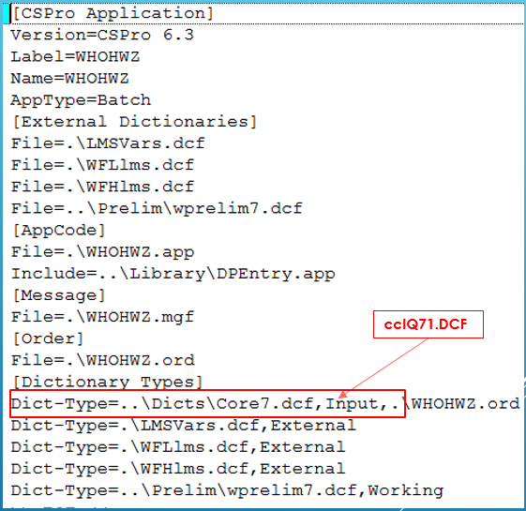Using a text editor, open the file “WHOHWZ.bch” and also change the dictionary name.
* After adjusting each file mentioned above, double click on the “WHOHWZ.bch” and CSPro will pop up some messages related to replacing the core dictionary variable by the new CS dictionary. Just click “Yes” until no more messages.
* Click the icon “Compile” for debugging until compile successfully.
* 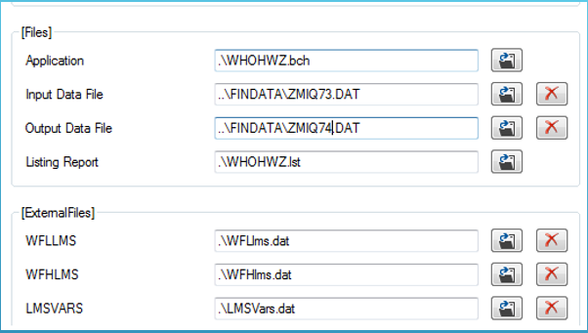To generate the .pff file, just run the application an enter the name of the input, output, and external data files:

# 15. Key Indicator Report

The Key Indicator report (KIR) discusses the main findings of the survey and is produced within the first month after completion of data entry. In general, these tables are generated from the imputed raw data after all previous steps define in this document have been implemented.

The KIR comprises around 20 tables. If the malaria module is part of the survey questionnarie, there are 6 additional tables that should be added to the KIR. There are 2 standard applications to produce the KIR tables: “Prelim7.app” (20 tables) and PrelMal7.app for malaria module only. The standard applications to produce the KIR tables can be found in SharePoint under the standard project, \prelim subfolder. For most of the surveys, additional tabulations are sometimes requested. Additional tables can be selected from the main report tables or to be designed from scratch. When the additional tables are taken from the Main Report the recode data set should be available.

To convert the standard KIR tables application to country specific, use the AtoQ utility, to adjust the generic names of the dictionary, variables and sections to the names actually used in the CS questionnaire(s). After running AtoQ, the names of variables that are not used in the questionnaire start (typically) with an “Z”. These variables should be excluded (braces out or deleted) from the application. Do all necessary adjustment until the application compile successfully.

Additional modifications might be needed and are listed below:

* The survey manager should provide to the DP specialist the standard KIR tabulation plan with all the alteration needed to become country specific; including adding/deleting tables, changes in the title, footnotes, columns titles, background variables, etc.
* After the application is completety debugged, navegate thru it from top to bottom, checking the logic for each table against the CS KIR tabulation plan.
* If the tables are to be produced in French or Spanish, then the comments around the table titles need to be adjusted accordingly; and the working storage dictionary should be adjusted too. The working storage dictionary is available in English, French and Spanish and can be found under the \prelim subfolder.
* The working storage dictionary is translated to
* Check if the result codes used in the survey agree with the standard. If this is not the case then the categories for the working variable HHRESULT/WRESULT/MRESULT should be adjusted, in the application and in working storage, according to the household, individual and male result codes.
* The denominator for the household response rate is all households that could have been interviewed or categories 1,2,4,5 and 8 respectively. If the household was absent (3) or the dwelling was vacant (6) or destroyed (7) or the result-code was classified as “other” (9), then the questionnaire is excluded from the denominator of the household response rate. This should be taken into account when there are country specific response codes. For the individual or male response rates all questionnaires are included in the denominator.
* The variable labels for the working variable REGION (or any other variables that are part of the survey domains) will need to be changed to include the actual names of regions in the country.
* When the education categories are different from the standard, then the categories for the working variable EDUC (derived from variables A107 and A108) should be modified.
* If the contraceptive table (ASEC31) is different from the standard, then the working variable for the contraceptive method currently used (METHOD and METHCOL) has to be adjusted accordingly. Also verify that the standard list of sources for contraceptive methods, i.e. SOURCE, agrees with the value labels in variables A318 and A328.
* Read carefully the instructions/comments written on the KIR application in reference to the vaccination tables and make the necessary changes accordingly to the list of vaccines included in the country’s questionnaire.

Check that the categories of all other variables declared in working storage agree with the assignments in the application.